Vacuum-Type Power Booster
Meets ASE Task: (A5-E-3) P-1 Inspect vacuum-type power booster unit for vacuum leaks; inspect the check valve for proper operation; determine needed action.

Name _______________________________ Date ___________ Time on Task __________

Make/Model/Year _________________ VIN ________________ Evaluation: 4 3 2 1

_____ 1. Check service information for the recommended procedures to follow to determine if
a vacuum-type power brake booster has a vacuum leak.
_________________________________________________________________
_________________________________________________________________
_________________________________________________________________

_____ 2. Most vacuum-type power boosters should be capable of supplying 3 or more assisted
stops with the engine off. How many were found? __________

_____ 3. Most vehicle manufacturers specify checking for leaks both around the outside (under
the hood), as well as in the valve area under the instrument panel.
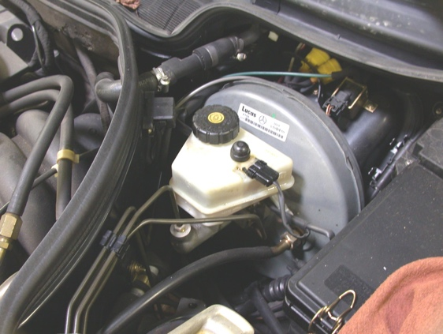
Under hood:

____ OK ____ NOT OK

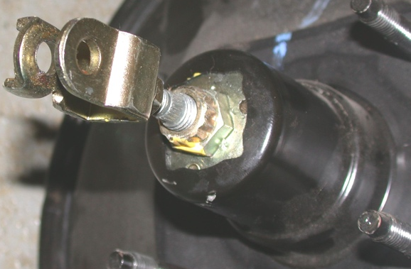

Valve area:

____ OK ____ NOT OK

_____ 4. Based on the test results, what is the needed action? __________________________

__________________________________________________________________

