Vacuum Supply/Manifold or Auxiliary Pump

Meets ASE Task: (A5-E-2) P-1 Check vacuum supply to vacuum-type power booster.

Name _______________________________ Date ___________ Time on Task __________

Make/Model/Year _________________ VIN ________________ Evaluation: 4 3 2 1

_____ 1. Check service information for the recommended procedures and specifications for
checking vacuum supply to power booster.

_________________________________________________________________

_________________________________________________________________

_________________________________________________________________

_____ 2. Is the vehicle equipped with an auxiliary vacuum pump? ____ Yes ____ No

_____ 3. Most vehicle manufacturers specify that a vacuum “T” be installed in the vacuum line
between the intake manifold and/or auxiliary pump and the vacuum power brake
booster assembly. Most manufacturers specify a minimum of 15 in. Hg. of vacuum be
measured.

Actual vacuum measured at the power brake booster = __________

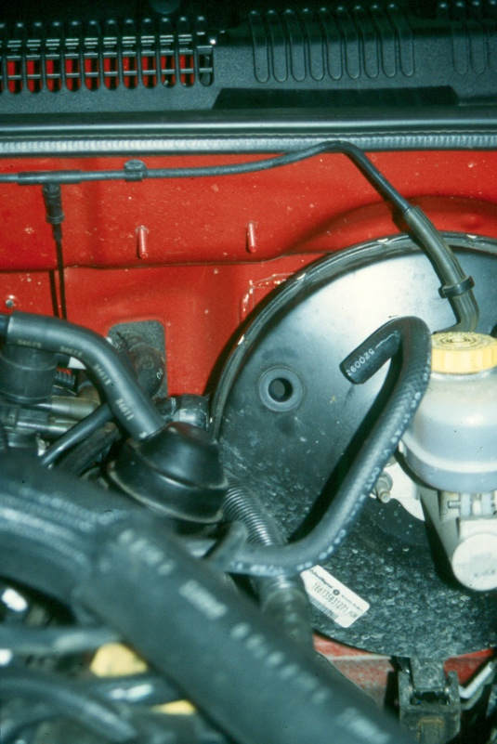
____ OK ____ NOT OK

