Vacuum Power Brake Booster Test

Meets ASE Task: (A5-E-1) P-2 Test pedal free travel; check power assist operation.

Name _______________________________ Date ___________ Time on Task __________

Make/Model/Year _________________ VIN ________________ Evaluation: 4 3 2 1

_____ 1. Check the service information for the specified procedure for testing a vacuum power
brake booster for the vehicle being serviced.

__________________________________________________________________

_____ 2. With the engine off, depress the brake pedal several times until the brake pedal feels
hard (firm).

_____ 3. The brake pedal should not fall to the floor of the vehicle.

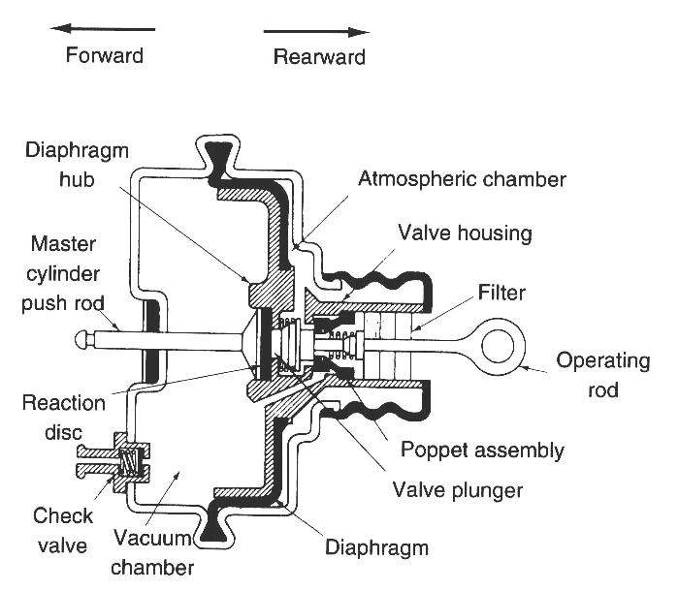
OK _____ NOT OK _____

NOTE: If the brake pedal travels to the floor
of the vehicle, carefully inspect the hydraulic
brake system for a fault. Service or repair the
hydraulic brake problem before continuing
with this test.

_____ 4. With your foot still firmly depressing the brake
pedal, start the engine. The brake pedal should
go down.
OK _____ NOT OK _____

_____ 5. If the brake pedal did not go down when the engine was started, visually check the
following:

_____ Minimum of 15 in. Hg of vacuum to the vacuum booster from the engine
manifold or auxiliary vacuum pump

_____ Proper operation of the one-way check valve

_____ Unrestricted charcoal filter between the booster and the intake manifold (if
equipped)

_____ Inspect for vacuum leaks

OK _____ NOT OK _____

