Brake Drum Service

Meets ASE Task: (A5-C-2) P-1, (A5-C-3) P-1 Inspect, measure, and machine brake drums.

Name _______________________________ Date ___________ Time on Task __________

Make/Model/Year _________________ VIN ________________ Evaluation: 4 3 2 1

_____ 1. Check service information for the exact specifications and procedures to follow when

inspecting, measuring, and machining brake drums. Describe specified procedures.

_________________________________________________________________

_________________________________________________________________

_____ 2. Measure the drum and compare to factory specifications:

Factory specification = ______________________

Measured drum inside diameter = _____________________

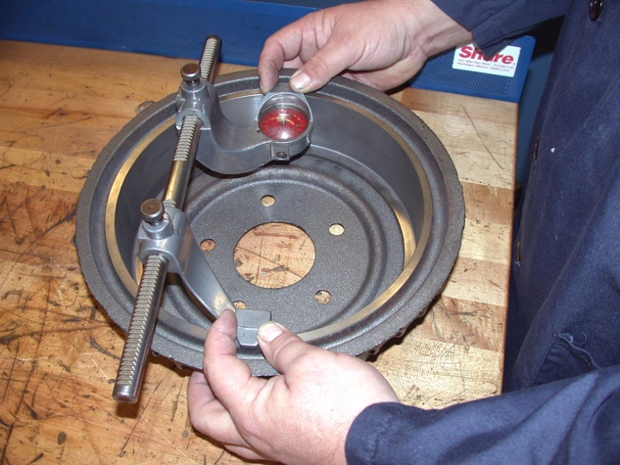
____ OK ____ NOT OK

_____ 3. Machine the brake drum. Instructor’s check ____________

_____ 4. What is the measurement of the drum after machining?

_____________________

