Parking Brake Operation

Meets ASE Task: (A5-F-4) P-1 Check parking brake operation; determine needed action.

Name _______________________________ Date ___________ Time on Task __________

Make/Model/Year _________________ VIN ________________ Evaluation: 4 3 2 1

_____ 1. Check service information for the specified procedure to follow when checking the
parking brake for proper operation.

__________________________________________________________________

__________________________________________________________________

__________________________________________________________________

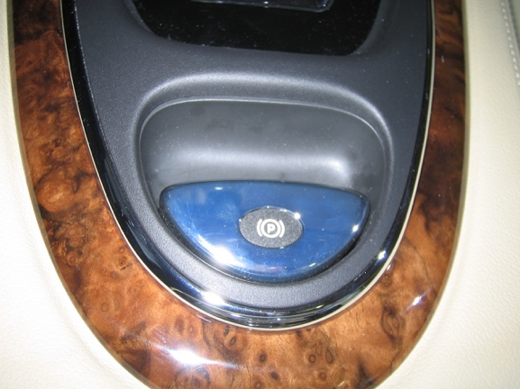
_____ 2. Identify the type of parking brake.

____ Foot operated

____ Hand operated

____ Push button

_____ 3. Most vehicle manufacturers specify that the parking brake be applied and that the
number of “clicks” required should be from 3 to 10. Apply the parking brake.

____ OK (within the specified number of clicks)

____ NOT OK (describe) __________________________________________

__________________________________________________________

_____ 4. Based on the check of the parking brake, what is the needed action?

________________________________________________________________

________________________________________________________________

