Parking Brake Adjustment

Meets ASE Task: (A5-F-3) P-1 Check parking brake cables and components for wear and clean or replace as needed.

Name _______________________________ Date ___________ Time on Task __________

Make/Model/Year _________________ VIN ________________ Evaluation: 4 3 2 1
_____ 1. Check the service information for the specified parking brake adjustment for the
vehicle being serviced. ________________________________________________
_____ 2. Apply the parking brake and count the number of “clicks.”
_____ less than 4 “clicks”
_____ 5 - 10 “clicks”
_____ over 10 “clicks”
NOTE: If there are less than 4 “clicks” or more than 10 “clicks”, adjustment of the parking brake may be needed.
_____ 3. Place the gear selector in neutral and release the parking brake.
_____ 4. Hoist the vehicle safely.
_____ 5. Try rotating the rear wheels (front wheels on some Subaru vehicles).
_____ rotates freely
_____ does not rotate
NOTE: If the rear wheels do not rotate, try loosening the parking brake cable.
_____ 6. If the rear wheels rotate freely and the parking brake requires more than 10 “clicks,”
remove the rear brakes for inspection.
NOTE: The parking brake should only be adjusted after checking and adjusting the rear brakes.
_____ 7. Clean and adjust the rear brakes.
_____ 8. Reassemble the rear brakes and apply the parking brake 3 - 4 “clicks.”
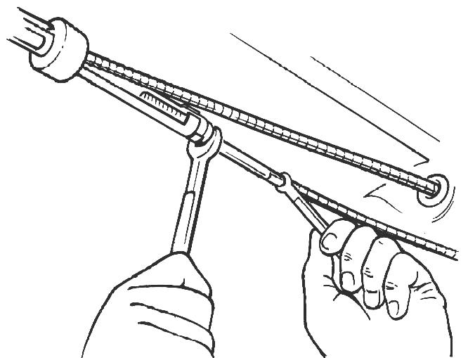
_____ 9. If the rear wheels can be rotated, adjust the parking
brake adjuster until the rear wheel brakes are just
touching the brake drums.
_____ 10. Apply the parking brake and again count the
“clicks.” Most vehicle manufacturers recommend
that the parking brake should hold with 6 to 18
“clicks.” Readjust the parking brake as needed.

