Rear Disc Parking Brake Adjustment

Meets ASE Task: (A5-D-10) P-2 Adjust calipers with integrated parking brake.

Name _______________________________ Date ___________ Time on Task __________

Make/Model/Year _________________ VIN ________________ Evaluation: 4 3 2 1

Many vehicles equipped with rear disc brakes use a mechanical activated parking brake that is integral with the caliper. Most are designed to be self-adjusting by adjusting when excessive brake pad-to-rotor clearance occurs.

_____ 1. Check the service information for the specified rear disc brake parking brake
adjustment procedure.
_________________________________________________________________

_____ 2. Check the number of “clicks” of the parking brake.

_____ Number of clicks (should be between 3 and 9)

OK _____ NOT OK _____

If over 10 clicks is needed to set the parking brake, the rear disc brake caliper needs
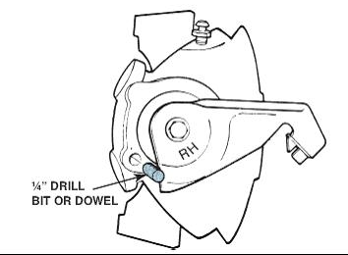
adjustment.

_____ 3. Hoist the vehicle safely and remove both rear wheels.

_____ 4. Carefully inspect the rear disc brakes for damage and
measure the pads for excessive wear.

OK _____ NOT OK _____

Replace the pads if worn to the minimum
allowable thickness.

_____ 5. If the disc brake pads are serviceable, operate the parking brake lever using the
appropriate size wrench on the actuating arm retaining bolt/nut while lightly tapping
on the caliper using a dead blow plastic hammer. The adjusting mechanism should
cause the piston to be repositioned with the correct pad to rotor clearance.

OK _____ NOT OK _____

If the proper clearance is not achieved, replacement of the calipers is required.

