Brake Pad Wear Indicator System

Meets ASE Task: (A5-D-11) P-1 Check brake pad wear indicator system operation; determine needed action.

**Name _______________________________ Date ___________ Time on Task __________**

**Make/Model/Year _________________ VIN ________________ Evaluation: 4 3 2 1**

_____ 1. Check service information for the specified procedure to follow when checking the

brake pad wear indicator system. Describe specified instructions: ________________

__________________________________________________________________

__________________________________________________________________

_____ 2. What type of brake pad wear indicates that the system was tested? (check all that

apply)

____ Wear sensor on pads (makes noise when pads are worn)

____ Dash warning lamp (triggered by the sensor in the brake)

____ Slits cut in the disc brake pads that indicate minimum allowable thickness

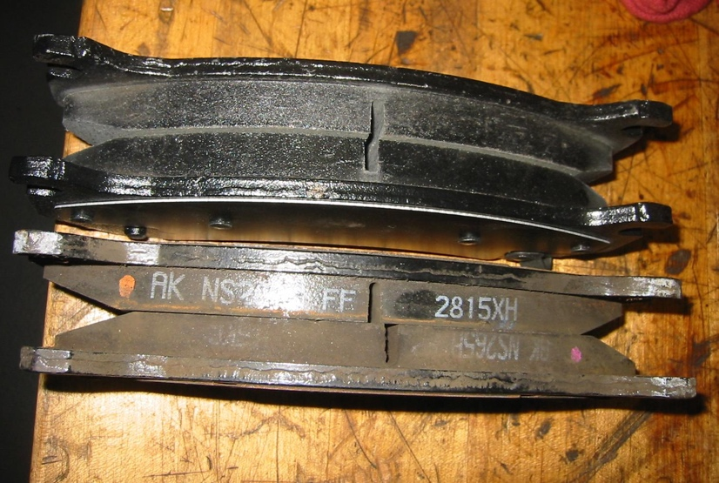

_____ 3. Based on the inspection of the brake pad wear indicator system, what is the needed

action?

**_________________________________________________________________**