Disc Brake Diagnosis and Service

Meets ASE Task: (A5-D-1) P-1, (A5-D-2) P-1, (A5-D-3) P-1, (A5-D-4) P-1, (A5-D-5) P-3

Disc brake caliper and related component inspection and service.

Name _______________________________ Date ___________ Time on Task __________

Make/Model/Year _________________ VIN ________________ Evaluation: 4 3 2 1

_____ 1. Check service information for the specified procedure to follow when diagnosing and

servicing disc brakes. Describe the recommended procedures.

_________________________________________________________________

_________________________________________________________________

_____ 2. Perform a thorough inspection of the disc brake system, including the condition of the

following:

A. Caliper (leaks or damage) ____ OK ____ NOT OK

B. Caliper mounts ____ OK ____ NOT OK

C. Brake pads ____ OK ____ NOT OK

_____ 3. Based on the inspection, what is the needed action? ___________________________

__________________________________________________________________

_____ 4. Disassemble, clean, and overhaul the disc brake calipers. Instructor’s check ______

_____ 5. Reassemble the disc brake assembly, seat the pads, bleed the brakes as needed.

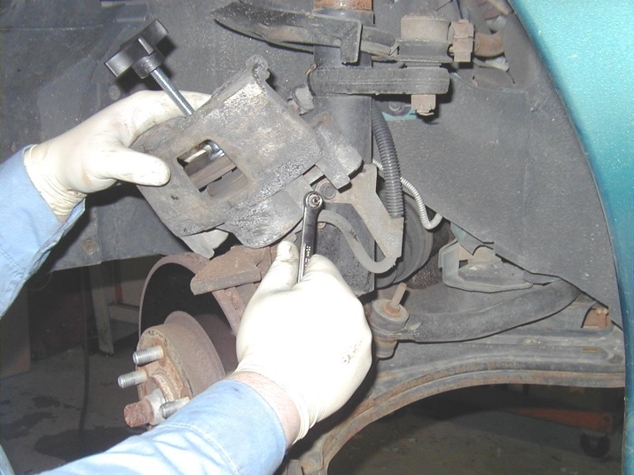
Instructor’s check ______

