Service Information
Meets ASE Task: (A1-A-2) P-1 Research vehicle and service information, vehicle history and TSBs.

Name _______________________________ Date ___________ Time on Task __________

Make/Model/Year _________________ VIN ________________ Evaluation: 4 3 2 1

Look up the following service information and record the page number or document number where the information was found.

Spark plug number: __________________ location found _____________

Spark plug gap: ________ location found _____________

Number of quarts of oil for an oil change: ______________ location found _____________

Viscosity of engine oil recommended: ________ location found _____________
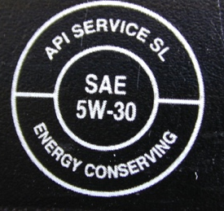

Air filter part number: _____________ location found _____________

Fuel filter part number: _____________ location found _____________

AC generator (alternator) output: ________ amps location found _____________

Bore and stroke of the engine: bore ______ stroke ______ location found _____________

Valve cover bolt torque specification: _________________ location found _____________

