Disc Brake Identification

Meets ASE Task: (A5-A-2) P-1 Research applicable vehicle and service information, such as brake system operation, vehicle service history, service precautions, and TSBs.

Name _______________________________ Date ___________ Time on Task __________

Make/Model/Year _________________ VIN ________________ Evaluation: 4 3 2 1

_____ 1. Check service information and/or check the vehicle to determine the following
information:

A. Type of brake system - ___ Disc front brakes/drum rear brakes
___ Disc front brakes/disc rear brakes

B. Type of disc brake caliper (check all that apply) –
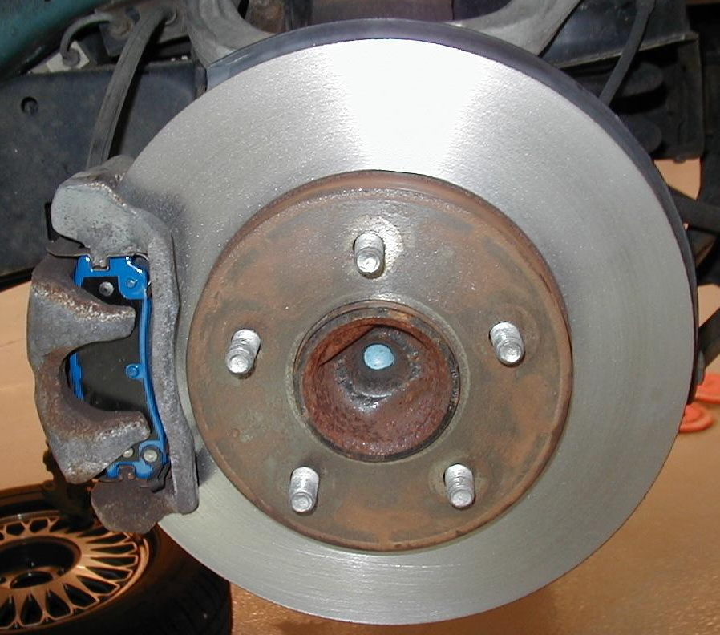
___ Floating
___ Sliding
___ Fixed ___ Single piston
___ Two pistons
___ Four or six pistons

C. Type of rotors (check all that apply)

___ Vented front
___ Vented rear
___ Solid front
___ Solid rear

D. Location of caliper (forward or
rearward) –

Front calipers = ____________
Rear calipers = ____________

E. What sensor or switch is used to turn on the red brake warning light in the
event of hydraulic failure?

___ Brake fluid level sensor
___ Pressure differential switch

