Install Wheel and Torque Lug Nuts
Meets ASE Task: (A5-A-4) P-1 Install wheel and torque lug nuts and make final checks and adjustments.

Name _______________________________ Date ___________ Time on Task __________

Make/Model/Year _________________ VIN ________________ Evaluation: 4 3 2 1

_____ 1. Check service information and determine the vehicle manufacturer’s specified lug nut
torque specification.

___________ (usually between 80 and 100 lb-ft)

_____ 2. Use a hand-operated wire brush on the wheel studs to ensure clean and dry threads and
check for damage.

OK _____ NOT OK _____ Describe fault: ____________________________

_____ 3. Verify that the lug nuts are OK and free of defects.

_____ 4. Install the wheel over the studs and start all lug nuts (or bolts) by hand.

_____ 5. Tighten the lug nuts a little at a time in a star pattern using an air impact wrench
equipped with the proper torque limiting adapter or a torque wrench.

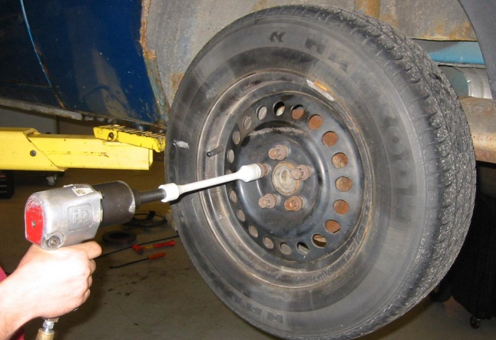
_____ Used a torque wrench

_____ Used an air impact with a torque
limiting adapter (torque stick)

_____ 6. Tighten the lug nuts to final torque in a star pattern.

NOTE: “Tighten one, skip one, tighten one” is the usual method if four or five
lug nuts are used.

