Drum Brake Service

Meets ASE Task: (A5-C-4) P-1, (A5-C-5) P-2, (A5-C-6) P-1 Check and replace drum brake assembly.

Name _______________________________ Date ___________ Time on Task __________

Make/Model/Year _________________ VIN ________________ Evaluation: 4 3 2 1

_____ 1. Check service information for the exact procedures to follow when inspecting and

replacing drum brake shoes and related hardware. Describe the recommended

procedures.

_________________________________________________________________

_________________________________________________________________

_____ 2. Remove, clean, and inspect the brake shoes and springs. Lubricate the backing plate.

Instructor’s check _______
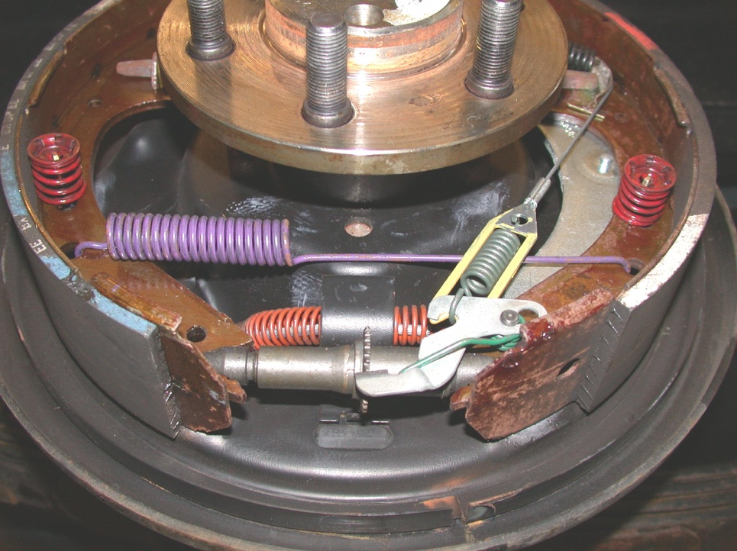

_____ 3. Inspect and install the wheel cylinders. Instructor’s check _______

_____ 4. Assemble the drum brake assemblies and adjust the parking brake and the brake

drums.

Instructor’s check _______

