Drum Brake Problem Diagnosis

Meets ASE Task: (A5-C-1) P-1 Diagnose drum brake concerns; determine needed action.

Name _______________________________ Date ___________ Time on Task __________

Make/Model/Year _________________ VIN ________________ Evaluation: 4 3 2 1

_____ 1. Verify drum brake problem concerns.
_____ Noise (describe) ____________________________________________
_____ Poor stopping
_____ Pulling (toward which side?) ________________________
_____ Grabbing (when?) ___________________________________________
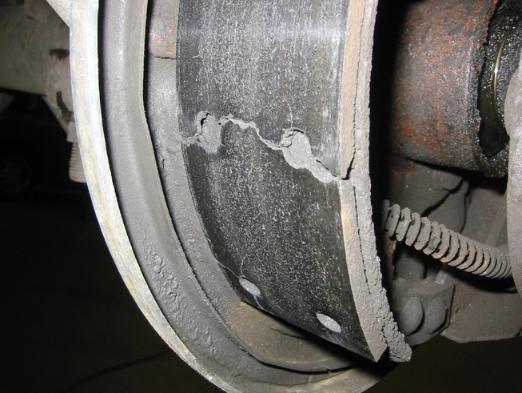
_____ Dragging
_____ Brake pedal pulsation

_____ 2. Hoist the vehicle safely.

_____ 3. Wet the brake drum or install a vacuum
enclosure to provide protection against
possible asbestos dust.

_____ 4. Remove the brake drums.

_____ 5. Describe the condition of the drum brake parts:

_____ Brake drum _________________________________________________
_____ Lining _____________________________________________________
_____ Springs ____________________________________________________
_____ Self-adjuster ________________________________________________
_____ Backing plate _______________________________________________

_____ 6. Based on the diagnosis, what is the needed action?

_________________________________________________________________

_________________________________________________________________

