Drum Brake Identification

Meets ASE Task: (A5-A-2) P-1 Research applicable vehicle and service information, such as brake system operation, vehicle service history, service precautions and TSBs.

Name _______________________________ Date ___________ Time on Task __________

Make/Model/Year _________________ VIN ________________ Evaluation: 4 3 2 1

_____ 1. Check service information and determine the following information regarding the
drum brake design and features for the vehicle (check all that apply):

___ Dual servo
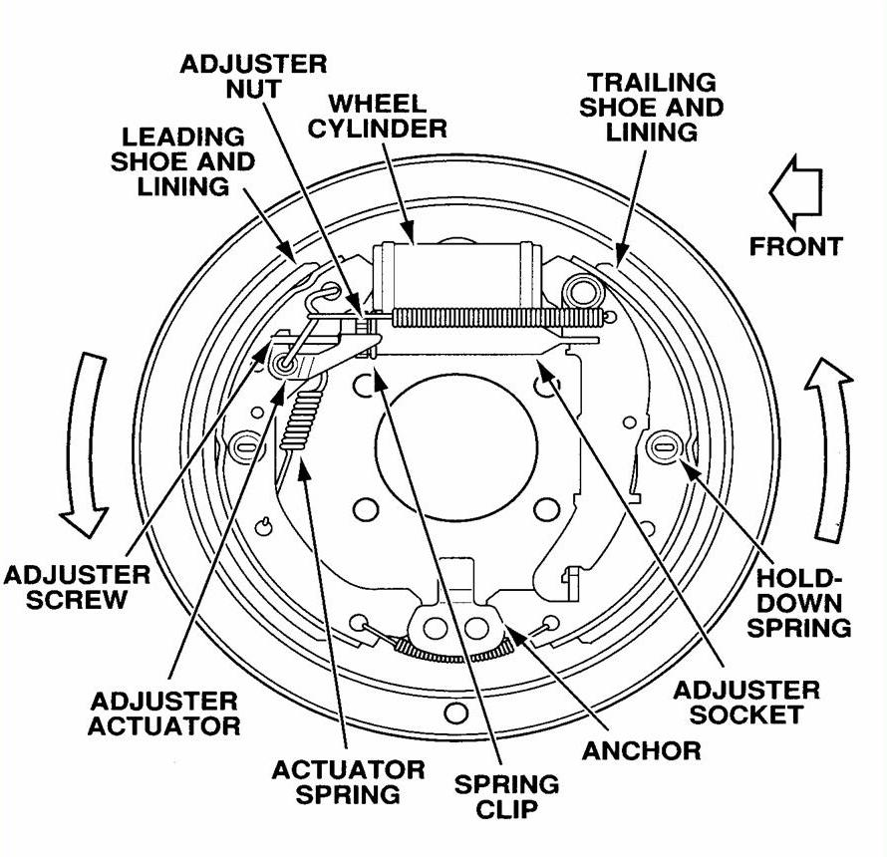
___ Leading trailing
___ Clip-on wheel cylinder
___ Bolted on wheel cylinder
___ Cast iron brake drum
___ Aluminum brake drum
___ Single U-spring design
___ Clip-type holddown
___ Coil-spring holddown
___ Cable-operated self adjust
___ Other (describe) _________
_____________________
_____________________

_____ 2. What is the brake drum diameter?

___________________________

_____ 3. What is the minimum allowable lining thickness?

________________________________

_____ 4. What is the maximum allowable brake drum diameter?

_________________________________

