Sealed Wheel Bearing Replacement

Meets ASE Task: (A5-F-7) P-1, (A3-D-3) P-1 Remove and install sealed wheel bearing assembly.

Name _______________________________ Date ___________ Time on Task __________

Make/Model/Year _________________ VIN ________________ Evaluation: 4 3 2 1

_____ 1. Check service information for the specified replacement procedure for the vehicle
being serviced. _______________________________________________________
________________________________________________________________

_____ 2. Loosen (do not remove) the drive axle shaft nut.

_____ 3. Hoist the vehicle safely to a good working height (about chest high).

_____ 4. Remove the front wheel.

_____ 5. Use a steel drift between the caliper and the rotor cooling vent hole to hold the rotor
from rotating.

_____ 6. Remove the drive axle shaft hub nut.

_____ 7. Remove the front disc brake caliper.

_____ 8. Remove the rotor, the hub, and splash shield retaining bolts.

_____ 9. Mark the location of the hub and make certain the hub is loose on the steering knuckle.
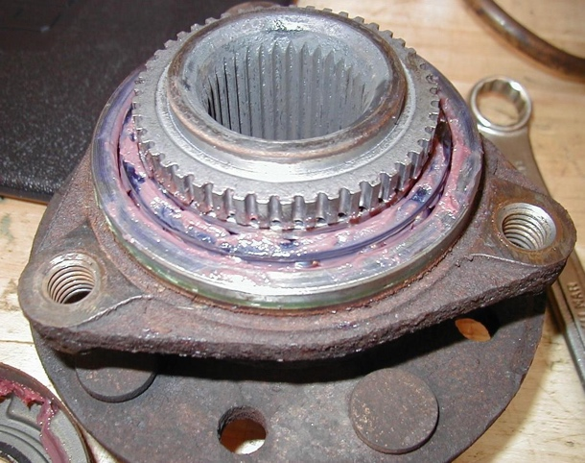
_____ 10. Install the hub puller and remove the
bearing and hub assembly.

_____ 11. Clean and lubricate hub bearing surface.

_____ 12. Reinstall the hub and bearing using the
drive axle shaft nut. (Do not torque to the
final setting, just until the hub is seated.)

_____ 13. Reinstall the rotor, caliper, and wheel.

_____ 14. Lower the vehicle and tighten the drive axle shaft nut to the final specification.
Specification = _______________ (usually about 200 lb.-ft.)

