Inspect and Replace Wheel Studs

Meets ASE Task: (A5-F-8) P-1 Inspect and replace wheel studs.

Name _______________________________ Date ___________ Time on Task __________

Make/Model/Year _________________ VIN ________________ Evaluation: 4 3 2 1

_____ 1. Hoist the vehicle safely.
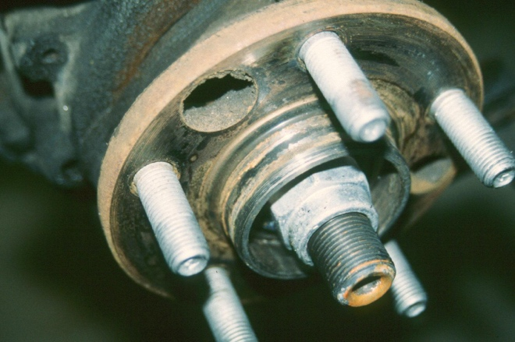
_____ 2. Remove all four wheels.

_____ 3. Carefully inspect the wheel studs for
excessive rust or damage.

LF = OK _____ NOT OK _____ Describe fault ______________________

RF = OK _____ NOT OK _____ Describe fault ______________________

LR = OK _____ NOT OK _____ Describe fault ______________________

RR = OK _____ NOT OK _____ Describe fault ______________________

_____ 4. Clean the threads using a stiff wire brush.

CAUTION: Many vehicle manufacturers specify that grease or oil should not be used on the threads of wheel studs. If a lubricant is used on the threads, the lug nuts could loosen during vehicle operation, which could cause a wheel to fall off resulting in a collision and possible personal injury.

_____ 5. Worn or damaged studs should be replaced. Check the service information for the
specified procedure for replacing wheel studs on the vehicle being serviced.

__________________________________________________________________

_____ 6. Which stud(s) were replaced? _____________________________________

