Wheel Bearing and Race Replacement

Meets ASE Task: (A5-F-6) P-3, (A4-D-2) P-1 Replace wheel bearing and race.

Name _______________________________ Date ___________ Time on Task __________

Make/Model/Year _________________ VIN ________________ Evaluation: 4 3 2 1

_____ 1. Remove the wheel cover and the hub
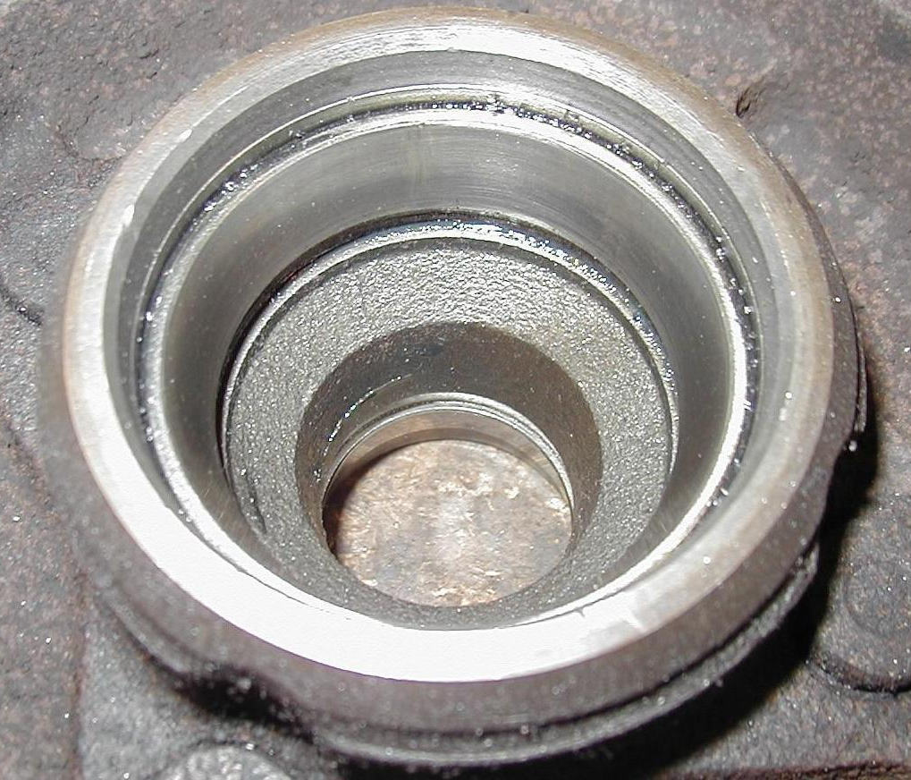
dust cap (grease cap).

_____ 2. Remove and discard the cotter key.

_____ 3. Remove the spindle nut, washer and outer bearing.

_____ 4. Remove inner and outer bearing and grease seal.

_____ 5. Remove the bearing race using the specified tool.

_____ 6. Show the instructor the removed race. Instructor's OK _______________

_____ 7. Install new race using the correct bearing race installation tool.

_____ 8. Show the instructor the new race. Instructor's OK _______________

_____ 9. Install a new grease seal using a seal installing tool.

_____ 10. Pack the new bearing with the correct type of wheel bearing grease.

_____ 11. Correctly adjust the bearing preload:

____ Install the spindle nut and while rotating the tire assembly, tighten (snug
only, 12 to 30 lb.-ft.) with a wrench to "seat" the bearing correctly in the
race.
_____ While still rotating the tire assembly, loosen the nut approximately 1/2 turn
and then hand tighten only.
_____ Install a new cotter key (the common size is 1/8” diameter and 1.5 inches
long).
_____ Bend the ends of the cotter key up and around the nut to prevent
interference with the dust cap.

_____ 12. Install the hub dust cap (grease cap) and wheel cover.

