Wheel Bearing Service

Meets ASE Task: (A5-F-2) P-2 Remove, clean, inspect, repack, and install wheel bearings.

Name _______________________________ Date ___________ Time on Task __________

Make/Model/Year _________________ VIN ________________ Evaluation: 4 3 2 1

_____ 1. Remove the wheel cover and the hub dust cap (grease cap).
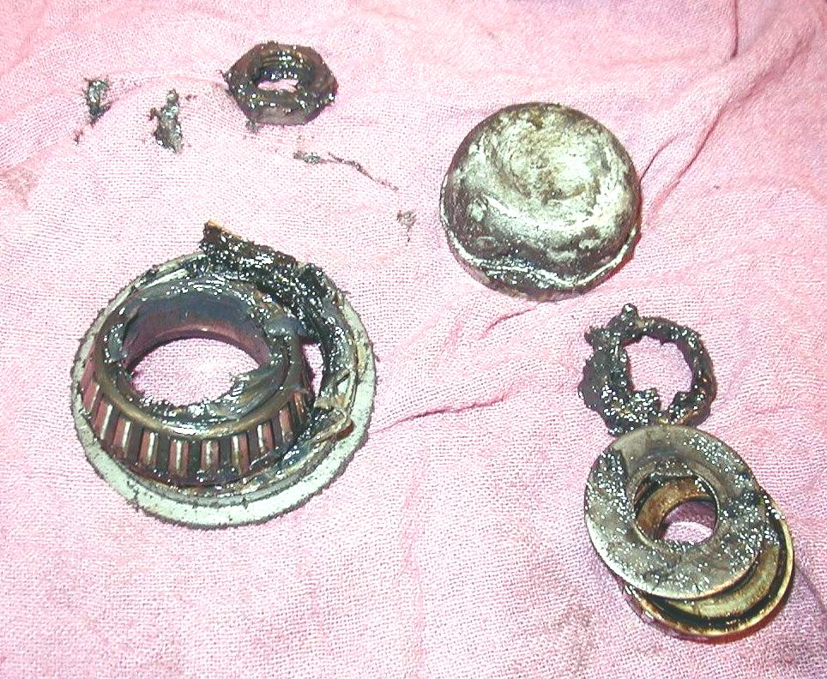
_____ 2. Remove and discard the cotter key.

_____ 3. Remove the spindle nut, washer and outer
bearing.

_____ 4. Remove inner and outer bearing and grease
seal.

_____ 5. Thoroughly clean the bearing in solvent and
denatured alcohol or brake cleaner and blow
it dry with compressed air.

_____ 6. Closely inspect the bearing for wear or
damage.

_____ 7. Show the instructor the cleaned bearing. Instructor's OK _______________

_____ 8. Repack the bearing with the correct type of wheel bearing grease.

_____ 9. Install a new grease seal using a seal installing tool.

_____ 10. Correctly adjust the bearing preload:

____ Install the spindle nut and while rotating the tire assembly, tighten (snug
only, 12 to 30 lb.-ft.) with a wrench to "seat" the bearing correctly in the
race.
_____ While still rotating the tire assembly, loosen the nut approximately 1/2 turn
and then hand tighten only.
_____ Install a new cotter key (the common size is 1/8” diameter and 1.5 inches
long).
_____ Bend the ends of the cotter key up and around the nut to prevent
interference with the dust cap.

_____ 11. Install the hub dust cap (grease cap) and wheel cover.

