Technical Service Bulletins
Meets ASE Task: (A1 through A8-A-2) P-1 Research vehicle service information, vehicle service history and TSBs.

Name _______________________________ Date ___________ Time on Task __________

Make/Model/Year _________________ VIN ________________ Evaluation: 4 3 2 1

_____ 1. Technical service bulletins can be accessed through (check all that apply):
____ Internet site(s), specify ________________________________________
____ Paper bulletins, specify source __________________________________
____ CD ROM bulletins, specify source _______________________________
____ Other (describe) ______________________________________________
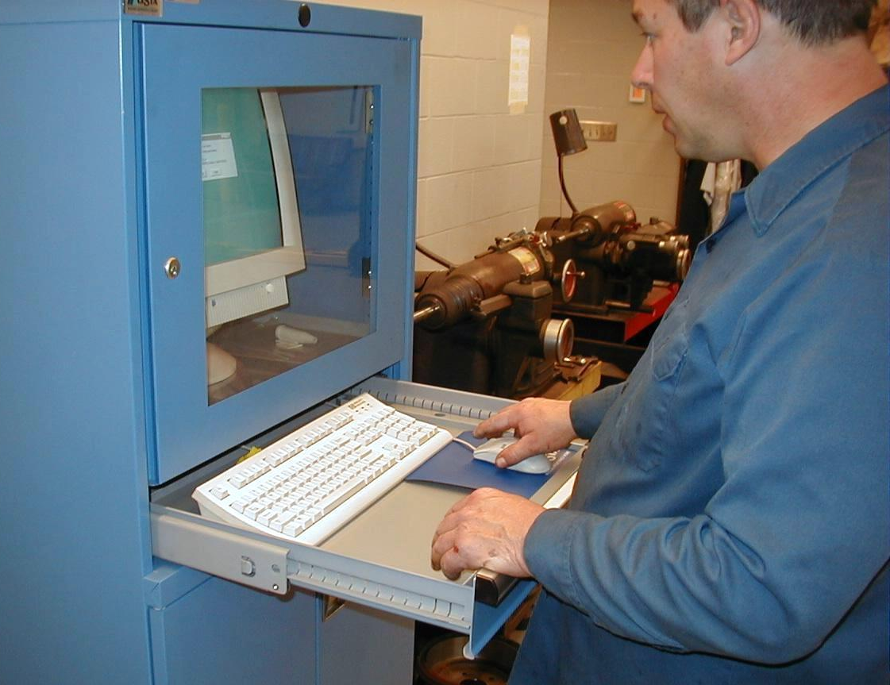

_____ 2. List all electrical-related technical service bulletins that pertain to the vehicle/engine
being serviced.
Number Description/Correction
________________ ________________________________________
________________ ________________________________________
________________ ________________________________________
________________ ________________________________________
_____ 3. Based on this research, is the information located helpful?
____ Yes, why? ___________________________________________________
____ No, why not? _________________________________________________

