Wheel Bearing Diagnosis
Meets ASE Task: (A5-F-1) P-1 Diagnose wheel bearing noises, wheel shimmy, and vibration concerns; determine needed action.

Name _______________________________ Date ___________ Time on Task __________

Make/Model/Year _________________ VIN ________________ Evaluation: 4 3 2 1

Worn or defective wheel bearings can cause a variety of concerns including:

Noise – usually a growl or rumble that changes tone with vehicle speed.
Wheel Shimmy – Can occur if the bearings are loose or excessively worn.
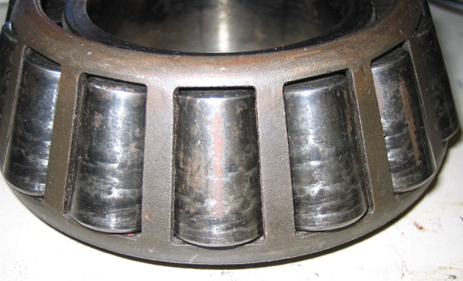
Vibration – Can occur if the bearings are loose or excessively worn.

_____ 1. Check service information for the
recommended test procedures to follow to
diagnose possible wheel bearing noise.

______________________________
______________________________

_____ 2. Drive the vehicle and check for abnormal noise that could be caused by a defective
wheel bearing.

OK _____ NOT OK _____

HINT: A defective wheel bearing often sounds like a noisy winter tire but does not change tone when the vehicle is being driven over various road surfaces.

_____ 3. Hoist the vehicle safely and check for excessive wheel bearing play and/or noise.

OK _____ NOT OK _____

Describe the faults and location: _______________________________________

_____ 4. Based on the diagnosis, what is the needed action? ___________________________
_________________________________________________________________
_________________________________________________________________

