Brake Bleeding

Meets ASE Task: (A5-B-12) P-1 Bleed and/or flush the brake system.

Name _______________________________ Date ___________ Time on Task __________

Make/Model/Year _________________ VIN ________________ Evaluation: 4 3 2 1

_____ 1. Check service information for the specified procedure to follow when bleeding and/or

flushing the brake system. Describe the specified procedure.

_________________________________________________________________

_________________________________________________________________

_____ 2. Perform a brake bleeding/flushing procedure. Instructor’s check _____________

_____ 3. Which method(s) was used (check all that apply)?

____ Normal (single stroke) method

____ Pressure bleeding

____ Vacuum bleeding

____ Gravity bleeding

____ Brake system was flushed

_____ 4. Was the use of a scan tool needed or suggested?

____ Yes (What scan tool?) ________________________________________

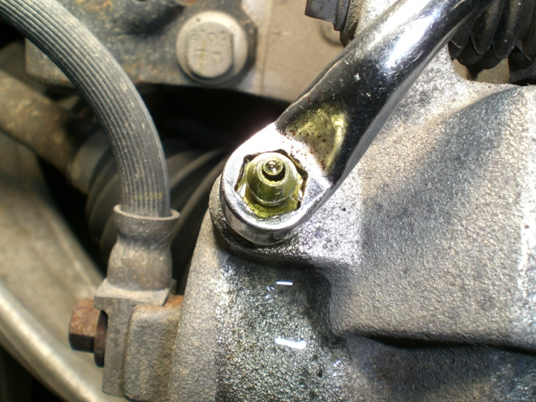
____ No

