Brake Fluid

Meets ASE Task: (A5-B-9) P-1, (A5-B-13) P-1 Brake fluid usage and test for contamination.

Name _______________________________ Date ___________ Time on Task __________

Make/Model/Year _________________ VIN ________________ Evaluation: 4 3 2 1

_____ 1. Check service information for the specified brake fluid and when to check for the

proper level.

A. Specified brake fluid = ____________________________________________

B. Specified brake fluid level _________ (describe the location) _____________

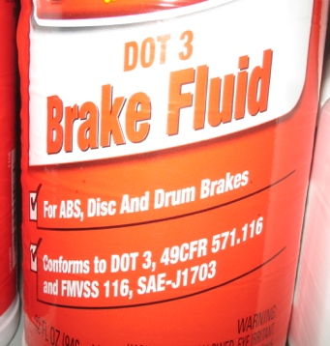

_____ 2. Check service information for the recommended procedure to follow to determine if

the brake fluid is contaminated. Describe the specified procedure:

__________________________________________________________________

__________________________________________________________________

_____ 3. Check all that apply according to service information.

____ Perform a visual inspection.

____ Place the sample in styrofoam cup and check for eating away of the cup at

the top of the fluid level line.

____ Use a test strip.

____ Use a brake fluid boiling temperature tester

____ Other (describe) ___________________________________________

