Red Brake Warning Lamp Diagnosis
Meets ASE Task: (A-5-B-10) P-3, (A5-B-11) P-2 Inspect, test and/or replace components of brake warning light system.

Name _______________________________ Date ___________ Time on Task __________

Make/Model/Year _________________ VIN ________________ Evaluation: 4 3 2 1

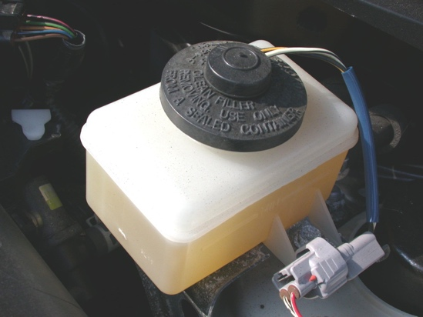
_____ 1. Does the vehicle use a brake fluid level sensor?

___ Yes ___ No

(If yes, describe the location: __________________________________.)

_____ 2. Does the vehicle use a pressure differential
switch?

___ Yes ___ No

(If yes, describe the location: _________________________________________.)

_____ 3. With the ignition key on, engine off (KOEO), apply the parking brake. Did the red
brake warning lamp light?

___ Yes ___ No

(If no, why not? ____________________________________________________)

_____ 4. Unplug the wiring connector from the brake fluid level sensor or pressure differential
switch. With the key on, engine off (KOEO), did the red brake warning lamp light?

___ Yes ___ No (It should not have come on.)

_____ 5. State the vehicle manufacturer’s recommended inspection, testing, and replacement
procedures:

__________________________________________________________________
__________________________________________________________________
__________________________________________________________________
__________________________________________________________________

