Hydraulic System Fault Analysis

Meet ASE Task: (A5-B-5) P-1 Diagnose braking concerns caused by hydraulic malfunctions.

Name _______________________________ Date ___________ Time on Task __________

Make/Model/Year _________________ VIN ________________ Evaluation: 4 3 2 1

Poor stopping or dragging brakes or pulling can be caused by hydraulic system failure or faults.

_____ 1. Check master cylinder for proper brake fluid level and condition.
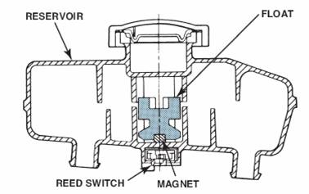
_____ 2. Verify proper operation of the base brakes.
_____ OK
_____ Pulls to the left during braking (see Step 3).
_____ Pulls to the right during braking (see Step 3).
_____ Brakes do not release fully (see Step 4).
_____ Poor stopping (see Step 5).
_____ Other brake system concerns (describe) ____________________________

_____ 3. Pulling can be caused by a stuck caliper piston on the side opposite the direction of the
pull.

If there is a pull to the right during braking, check the left side caliper.

OK ____ NOT OK ____

If there is a pull to the left during braking, check the right side caliper.

OK ____ NOT OK ____

_____ 4. Brakes that do not fully release can be caused by a fault with the flexible brake hose
and/or a stuck caliper piston

Visually check the flexible brake hose. OK ____ NOT OK ____

Check that the caliper piston can be moved into the caliper bore easily.

OK ____ NOT OK ____

_____ 5. Poor stopping can be caused by a stuck caliper or wheel cylinder piston. Check that
all hydraulic pistons are free.

LF = OK ____ NOT OK ____
RF = OK ____ NOT OK ____
LR = OK ____ NOT OK ____
RR= OK ____ NOT OK ____

