Master Cylinder Service
Meet NATEF Task: (A5-B-3) P-1, (A5-B-4) P-1 Check master cylinder for external and internal leaks and proper operation; remove, bench bleed, and reinstall master cylinder.

Name _______________________________ Date ___________ Time on Task __________

Make/Model/Year _________________ VIN ________________ Evaluation: 4 3 2 1

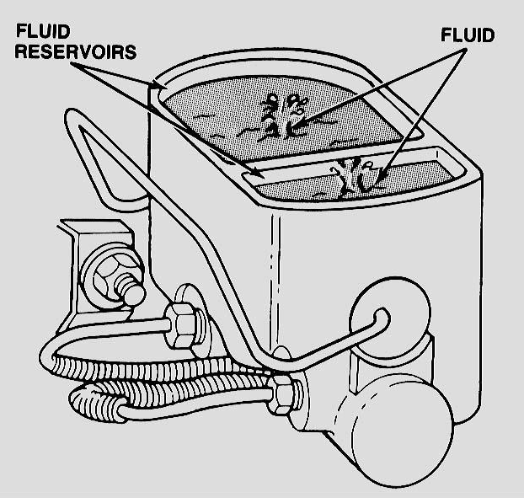
_____ 1. Check visually for signs of external brake fluid
leaks.

_____ OK _____ NOT OK

Describe location _____________________

_____ 2. Check for internal leakage by observing the
level of brake fluid in the front compared
to the rear.

A. Is the level higher in the front than the rear? ____ Yes ____ No

B. Is the brake pedal lower than normal? ____ Yes ____ No

If yes to both A and B above, then the master cylinder is leaking internally and must
be replaced.

_____ 3. Have an assistant depress the brake pedal while watching the brake fluid in the master
cylinder reservoir. The brake fluid should be seen to move as the brake pedal is being
depressed if the sealing caps are OK and positioned correctly.

Movement observed? ____ Yes ____ No

If brake fluid does not move and there is a braking system problem, the master
cylinder or linkage adjustment is faulty.

_____ 4. Based on the test results, what is the needed action? __________________________

_________________________________________________________________

