Brake Pedal Height
Meet ASE Task: (A5-B-2) P-1 Measure brake pedal height; determine needed action.

Name _______________________________ Date ___________ Time on Task __________

Make/Model/Year _________________ VIN ________________ Evaluation: 4 3 2 1

_____ 1. State the vehicle manufacturer’s specified brake height testing procedure:

__________________________________________________________________
__________________________________________________________________
__________________________________________________________________

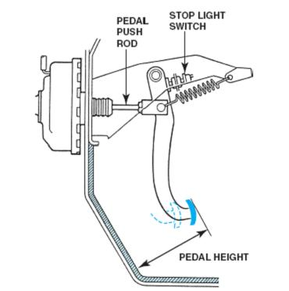
_____ 2. Measure the brake pedal height from the bottom

of the steering wheel or floor to the brake pedal.

________ = inch (cm)

_____ 3. Depress the brake pedal until the brakes are

applied and measure the brake pedal height.

________ = inch (cm)

_____ 4. Subtract the second reading from the first

reading. This is the brake pedal travel.

_______ = brake pedal travel (should be a maximum of 2.0 to 2.5 in.)

_____ 5. List three items that could cause a greater than normal brake pedal travel.

A. _______________________________

B. _______________________________

C. _______________________________

_____ 6. Based on the test results, what is the needed action: ___________________________

_________________________________________________________________

