Hydraulic Pressure Analysis
Meet ASE Task: (A5-B-1) P-1 Diagnose pressure concerns in the brake system using hydraulic principles.

Name _______________________________ Date ___________ Time on Task __________

Make/Model/Year _________________ VIN ________________ Evaluation: 4 3 2 1

_____ 1. Remove the disc brake calipers and install a force gauge between the caliper piston
and the caliper housing.

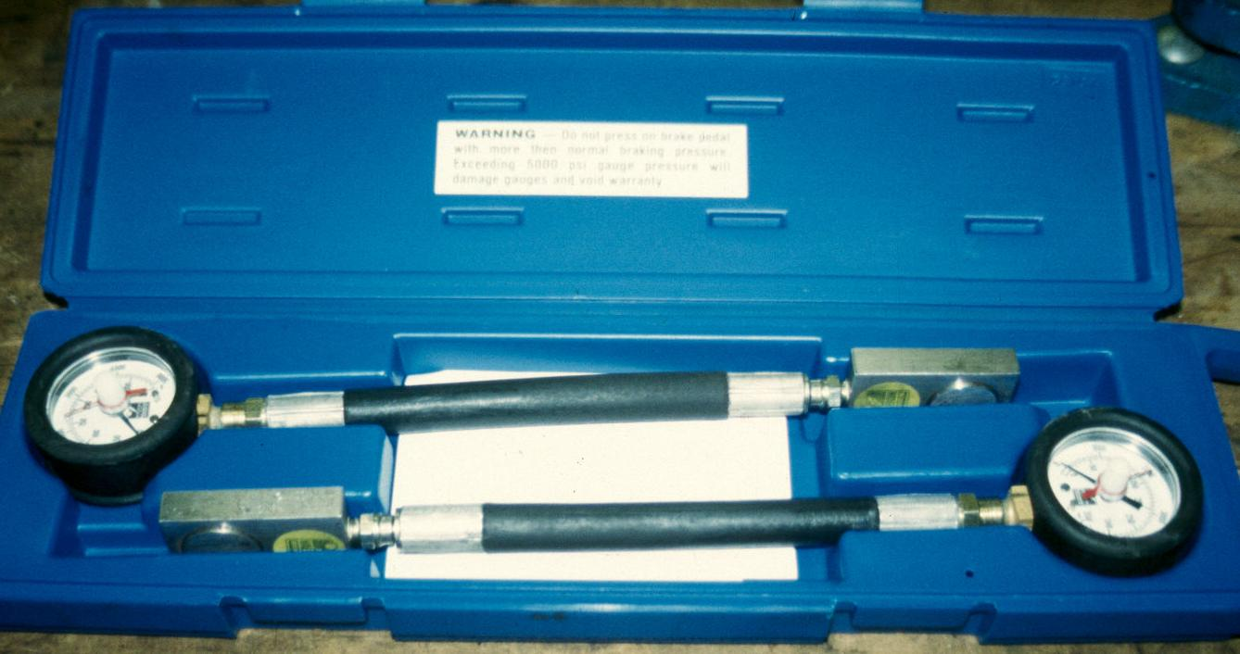

_____ 2. Depress the brake pedal and observe the force readings.

Left side = ______ pounds Right side = ______ pounds

The readings should be the same. OK _____ NOT OK _____

_____ 3. List possible causes that could prevent the force reading to be different from one side
to the other.

A. ___________________________________________________
B. ___________________________________________________
C. ___________________________________________________

_____ 4. Based on the test results, what is the needed action?

_________________________________________________________________

_________________________________________________________________

