Brake System Component Identification

Meets ASE Task: (A5-A-2) P-1 Research applicable vehicle and service information, such as brake system operation, etc.

Name _______________________________ Date ___________ Time on Task __________

Make/Model/Year _________________ VIN ________________ Evaluation: 4 3 2 1

_____ 1. Front disc brake design type (check all that apply):

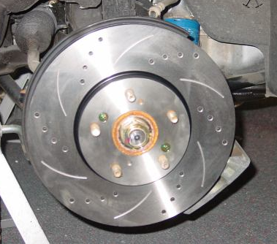
___ A. Single piston caliper
___ B. Piston caliper
___ C. Four or six piston caliper
___ D. Fixed-type caliper design
___ E. Floating- or sliding-type caliper design

_____ 2. Front rotor:

___ A. Vented
___ B. Solid

_____ 3. Rear brakes (check all that apply):

___ A. Drum brakes
___ B. Disc brakes with integral parking brake
___ C. Disc brake with auxiliary parking drum brake
___ D. Other (describe) ___________________________________

_____ 4. Type of parking brake application:

___ Hand operated
___ Foot operated
___ Electric

_____ 5. Type of parking brakes (check which):

___ Drum brake
___ Part of rear disc brake
___ Separate drum brake along with rear disc brake
___ Other (describe) __________________________________________

