Oxy-Acetylene Torch Usage
Meets ASE Task: (Not Specified by ASE)

Name _______________________________ Date ___________ Time on Task __________

Make/Model/Year _________________ VIN ________________ Evaluation: 4 3 2 1

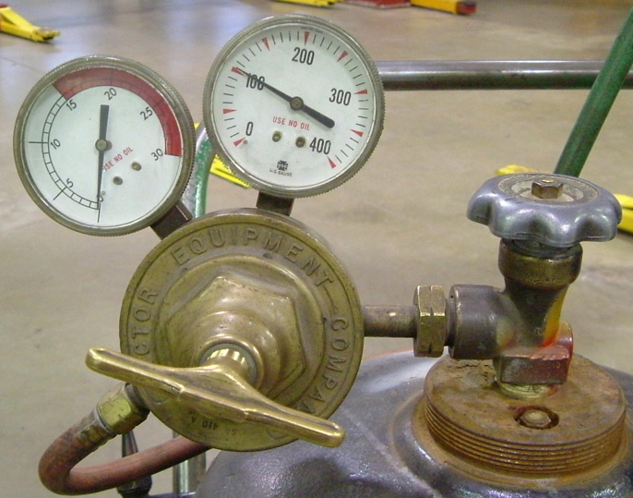
Caution: Proper operation of an oxy-acetylene torch requires proper instruction and willingness to follow all safety precautions.

Instructor check that proper instruction has been given on the safe use of the oxy-acetylene torch.

__________________________

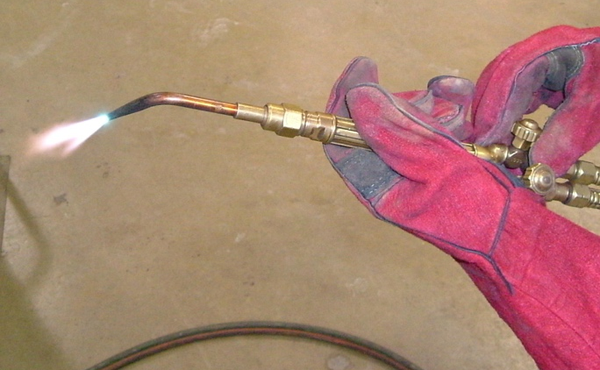
_____ 1. Setup the torch and pressures to heat metal.

Oxygen pressure set to __________

Acetylene pressure set to _________

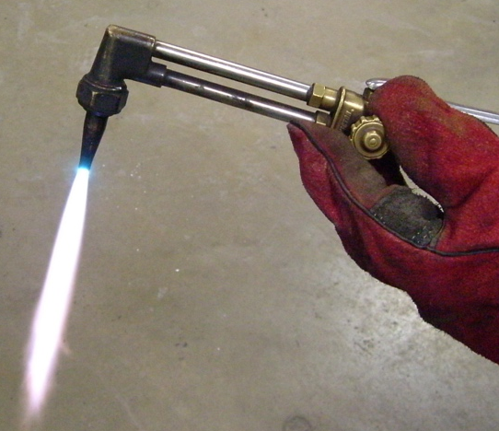
Instructor’s OK _________________

_____ 2. Setup torch to cut metal.

Oxygen pressure set to _________

Acetylene pressure set to _________

Instructor’s OK _________________

