Noise and Vibration Diagnosis
Meets ASE Tasks: (A3-D-5) P-2, (A4-A-1) P-1, (A4-D-5) P-2 Diagnose wheel/tire vibration, shimmy, and noise; determine needed action.

Name _______________________________ Date ___________ Time on Task __________

Make/Model/Year _________________ VIN ________________ Evaluation: 4 3 2 1

_____ 1. Check service information for the specified (if any) methods and procedures to follow
when diagnosing noise and/or vibration concerns.

__________________________________________________________________
__________________________________________________________________

_____ 2. Test drive the vehicle and verify the concerns. Check all that apply:

___ Noise ___ Vibration ___ Both

_____ 3. If there is a vibration, what frequency and at what speed is the vibration?

Frequency _________ Vehicle speed _________
Frequency _________ Vehicle speed _________
Frequency _________ Vehicle speed _________
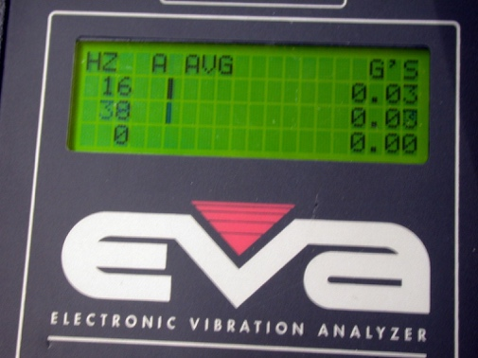
Frequency _________ Vehicle speed _________

_____ 4. If a noise, check for witness marks and describe this location: ___________________

__________________________________________________________________

_____ 5. Based on the test results and visual inspection, what is the needed action?

__________________________________________________________________

