Power and Shop Equipment Safety Survey

Meets ASE Task: (Not specified by ASE)

Name _______________________________ Date ___________ Time on Task __________

Make/Model/Year _________________ VIN ________________ Evaluation: 4 3 2 1

_____ 1. Check the power and shop equipment in the shop, at a local shop, or dealer. Where

was this survey taken? ________________________________________________

_____ 2. List all shop equipment, such as hoists, floor jacks, and cranes, and not whether they

are equipped with all needed safety devices.

Shop Equipment Safety devices? If not, list:

_____________________________ Yes__ No__ (describe) ________________

_____________________________ Yes__ No__ (describe) ________________

_____________________________ Yes__ No__ (describe) ________________

_____________________________ Yes__ No__ (describe) ________________

_____________________________ Yes__ No__ (describe) ________________

_____________________________ Yes__ No__ (describe) ________________

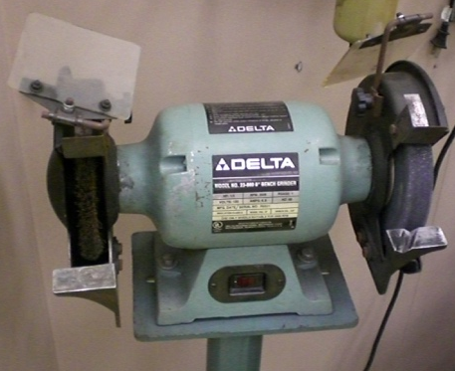
_____ 3. List all power equipment, such as trouble

lights, grinders, etc. and note whether they

are equipped with all needed safety devices.

Power Equipment Safety devices? If not, list:

_____________________________ Yes__ No__ (describe) ________________

_____________________________ Yes__ No__ (describe) ________________

_____________________________ Yes__ No__ (describe) ________________

_____________________________ Yes__ No__ (describe) ________________

_____________________________ Yes__ No__ (describe) ________________

