Diagnostic Alignment Angles

Meets ASE Task: (A4-E-7) P-2, (A4-E-8) P-3 Check angles that can detect collision damage; determine needed action.

Name _______________________________ Date ___________ Time on Task __________

Make/Model/Year _________________ VIN ________________ Evaluation: 4 3 2 1

_____ 1. Measure the rear thrust angle and compare it to factory specifications.
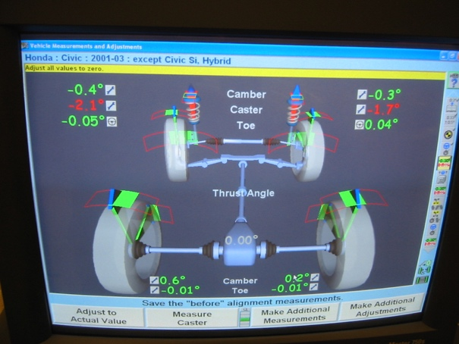

Measured rear thrust angle = __________________

Specified thrust angle = ___________________

_____ 2. Based on the results of the rear thrust angle

measurement, what is the needed action.?

_________________________________________

_________________________________________

_____ 3. Measure the front wheel setback and compare it to factory specifications.

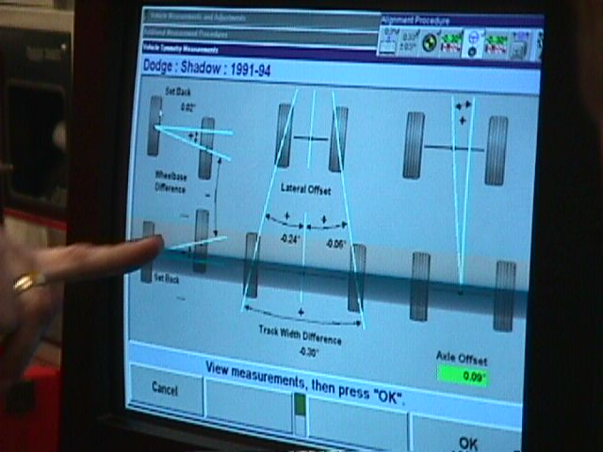
Measured front wheel setback = __________________

Specified front wheel setback = ___________________

_____ 4. Based on the results of the front wheel setback

measurement, what is the needed action.?

_________________________________________

_________________________________________

_____ 5. Check service information for the specified location and dimensions to check for the

proper alignment of the front and/or rear cradle (subframe).

__________________________________________________________________

__________________________________________________________________

_____ 6. Based on the results of the measurements, compared to factory specifications, what is

the needed action?

__________________________________________________________________

