TOOT and SAI

Meets ASE Task: (A4-E-4) P-2, (A4-E-5) P-2 Check toe-out-on-turns (turning radius) and SAI (steering axis inclination) and included angle; determine needed action.

Name _______________________________ Date ___________ Time on Task __________

Make/Model/Year _________________ VIN ________________ Evaluation: 4 3 2 1

_____ 1. Check the alignment equipment instructions and measure the toe-out-on-turns.

LEFT TOOT RIGHT TOOT

___________ _____________
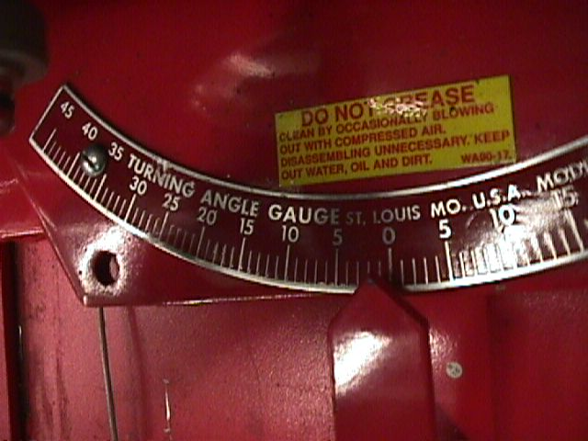

_____ 2. Check service information for the specified toe-out-on-turns

(TOOT).

Specifications = ____________________________

_____ 3. Based on the TOOT readings, what is the needed action?

__________________________________________________________________

__________________________________________________________________

_____ 4. Check steering axis inclination (SAI) and compare to factory specifications.

SAI LEFT SAI RIGHT

_________ __________

Specification for SAI = ________________________________

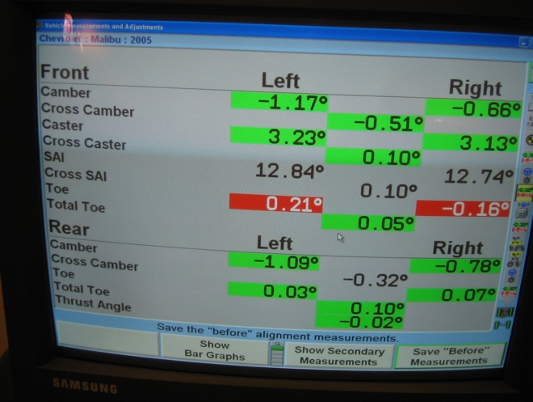

_____ 5. Based on the SAI reading, what is the

needed action?

__________________________________

__________________________________

__________________________________

