**Alignment Angle Readings**

Meets ASE Task: (A4-E-3) P-1 Prepare vehicle for wheel alignment on the alignment machine; perform four-wheel alignment by checking and adjusting wheel caster.

**Name _______________________________ Date ___________ Time on Task __________**

**Make/Model/Year _________________ VIN ________________ Evaluation: 4 3 2 1**

**_____ 1.** Hoist the vehicle on the alignment rack and install the wheel sensors.

**_____ 2.** Compensate the wheel sensors as per the alignment equipment manufacturer’s

recommended procedure.

**_____ 3.** Lower the vehicle and jounce (bounce) to center the suspension.

**_____ 4.** Read the rear camber and toe.

**LR RR**

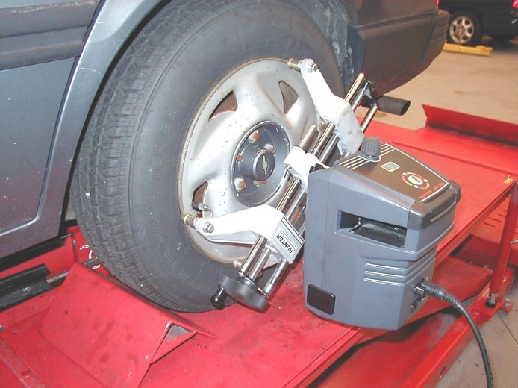

Camber _____ _____

Toe _____ _____

Total rear toe = _______

**_____ 5.** Read the front camber and toe.

**LF RF**

Camber _____ _____

Toe _____ _____

Total front toe = _______

**_____ 6.** Perform a caster sweep to determine the front caster and SAI.

**LF RF**

Caster _____ _____

SAI _____ _____

Describe what (if anything) is wrong with the present alignment.

___________________________________________________