Pre-Alignment Inspection
Meets ASE Task: (A4-E-2) P-1 Perform prealignment inspection and measure vehicle ride height; perform needed action.

Name _______________________________ Date ___________ Time on Task __________

Make/Model/Year _________________ VIN ________________ Evaluation: 4 3 2 1

_____ 1. Check tires. Both front tires and both
rear tires should be checked for the
following:

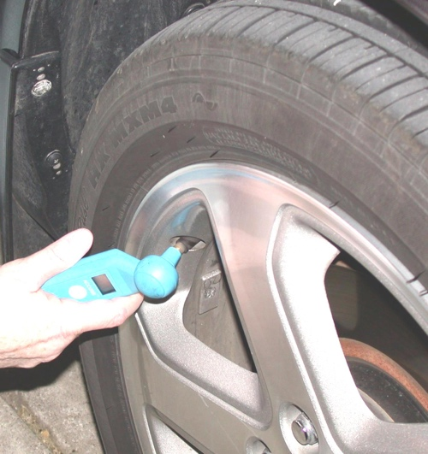
A. Correct tire pressure

B. Same size and brand

C. Same tread depth

OK _____ NOT OK _____

_____ 2. Perform a dry-park test to check for any looseness in the steering and suspension
components such as:

A. Tie rods

B. Idler arms

C. Ball-joints

D. Control arm bushings

E. Loose or defective wheel bearings

OK _____ NOT OK _____

_____ 3. Check for proper ride height.

A. Front and rear

B. Left and right

OK _____ NOT OK _____

