Drive Axle Shaft Service

Meets ASE Task: (A3-E-3.2) P-2, (A3-D-4) P-1 Remove and replace drive axle shafts.

Name _______________________________ Date ___________ Time on Task __________

Make/Model/Year _________________ VIN ________________ Evaluation: 4 3 2 1

_____ 1. Check service information for the specified procedure to follow when inspecting and

replacing drive axle shafts. Describe specified procedure. ________________________

____________________________________________________________________

____________________________________________________________________
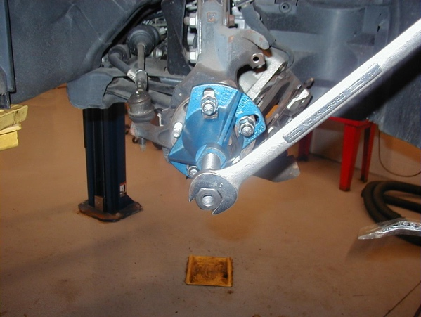

_____ 2. List the tools required. Check all that apply:
____ Lug nut wrench
____ Torque wrench
____ Spindle nut socket
____ CV boot protector
____ Axle puller
____ Other (describe) ____________________________________________
________________________________________________________
_____ 3. Inspect bearings, seals, and retainers. ___________________________________
_____ 4. Measure drive axle flange runout. What is the needed action? _______________
______________________________________________________________
______________________________________________________________

