U-Joint and CV Joint Service
Meets ASE Task: (A3-E-3.2) P-1, (A3-E-3.3) P-2, (A3-E-3.4) P-2, (A3-E-3.5) P-2 Inspect, service, and replace shafts, shaft center support bearings yokes, boots, and CV joints; check shaft balance and phasing.

Name _______________________________ Date ___________ Time on Task __________

Make/Model/Year _________________ VIN ________________ Evaluation: 4 3 2 1

_____ 1. Check service information and determine the specified procedures, tools, and torque
specification needed to service CV joints.

Specified procedure: ________________________________________________
___________________________________________________________
Tools/equipment: ___________________________________________________
___________________________________________________________
Torque specification: ________________________________________________

_____ 2. Following the specified procedure, remove the drive axle shaft assembly.
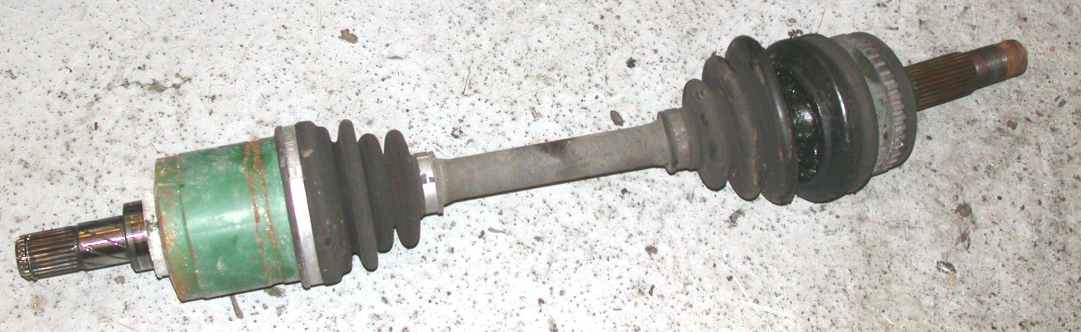
Instructor’s check ____________

_____ 3. Following the specified installation procedure, check all that were replaced.

___ Drive axle shaft assembly ___ CV joint and boot
___ CV joint boot only ___ Other (specify) ___________________

_____ 4. Reinstall the drive axle shaft assembly.

Instructor’s OK ______________

