Hand Tool Identification

Meets ASE Task: (Not specified by ASE)

Name _______________________________ Date ___________ Time on Task __________

Make/Model/Year _________________ VIN ________________ Evaluation: 4 3 2 1

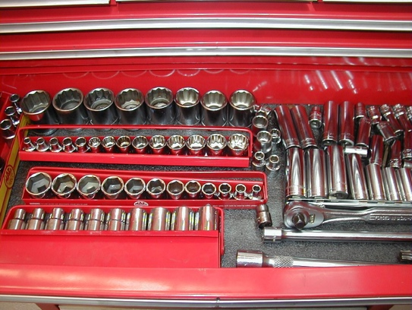
_____ 1. List the sizes of wrenches you have in
your tool box. ______________________
_______________________________
_______________________________
What sizes are missing or will need to be
purchased? _________________________
_______________________________
_____ 2. List the sizes of the 1/4 inch drive sockets you have in your tool box. _____________
__________________________________________________________________
What sizes are missing or will need to be purchased? __________________________
__________________________________________________________________
_____ 3. List the sizes of the 3/8 inch drive sockets you have in your tool box. _____________
__________________________________________________________________
What sizes are missing or will need to be purchased? __________________________
__________________________________________________________________
_____ 4. List the sizes of the 1/2 inch drive sockets you have in your tool box. ____________
__________________________________________________________________
What sizes are missing or will need to be purchased? __________________________
__________________________________________________________________
_____ 5. List the other tools you have in your tool box including hammers, screwdrivers,
pliers, and other items. __________________________________________________
__________________________________________________________________
List additional tools that you wish to add to your tool box. ______________________
__________________________________________________________________

