Temporary Disabling of an Airbag
Meets NATEF Task: (A6-H-5) Disarm and enable the airbag system for
vehicle service. (P-1)

Name _______________________________ Date ___________ Time on Task __________

Make/Model/Year _________________ VIN ________________ Evaluation: 4 3 2 1

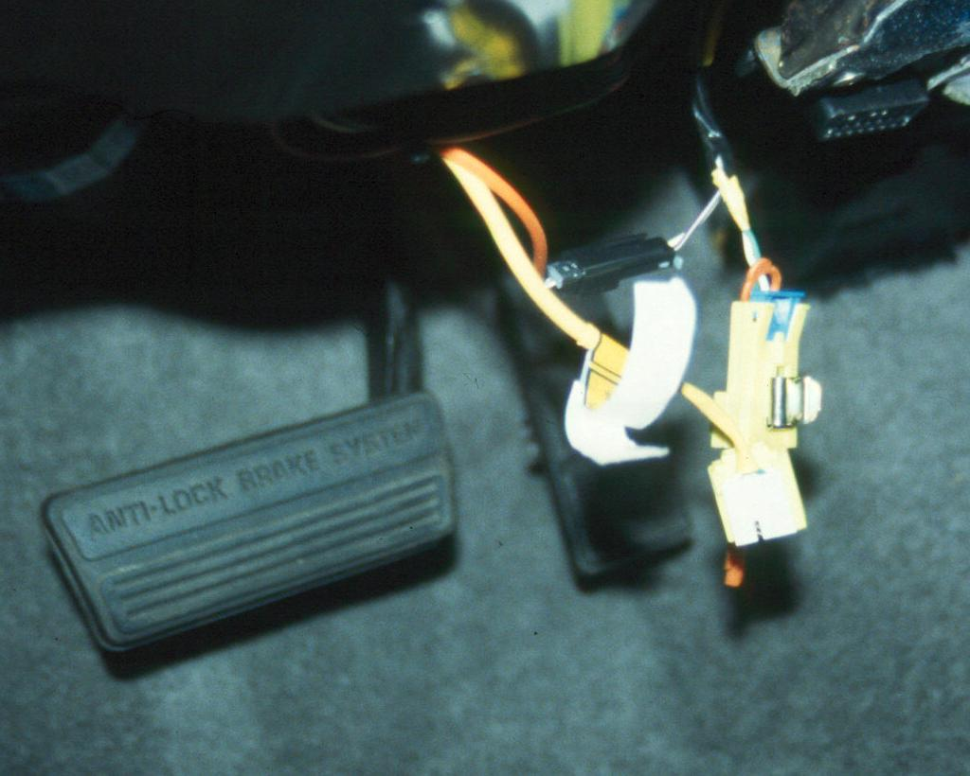
To safely work on the steering system of any vehicle that is equipped with an airbag (supplemental restraint system [SRS] or supplemental inflatable restraints [SIR]), it is important that the airbag(s) be temporarily disabled and reconnected after the steering service work has been performed.

_____ 1. Disconnect the negative (-) terminal of the battery.

_____ 2. Locate and remove the fuse for the airbags.

HINT: The fuse for the airbag(s) often has a yellow
band around the fuse to identify the airbag fuse.

_____ 3. How was the specific fuse labeled that needed to be removed to disable the airbag?

____________________________________________

_____ 4. Disconnect the yellow electrical connector at the base of the steering column to open
the circuit to the driver's side airbag.

CAUTION: This is an important step. The airbag could be deployed even without battery power, because the airbag computer module contains a capacitor that can trigger the airbag in the event that power is lost during an accident.

_____ 5. Disconnect the connector for the passenger's side airbag (if equipped).

Location of the connector ________________________________________

Instructor's OK __________________________

_____ 6. After all service work has been completed on the vehicle, restore the operation of the
airbag(s) by reconnecting the electrical connectors and installing the airbag fuse and
the battery connections.

_____ 7. Start the engine and verify proper operation of the dashboard airbag warning light.

