Automotive Steering, Suspension, & Alignment 7e

Chapter 8 Rear Suspension

Opening Your Class
KEY ELEMENT | EXAMPLES
Introduce Content | This course or class covers operation and service of Automotive Steering and Suspension Systems with Wheel Alignment and Drive Axles. It correlates material to task lists specified by ASE and NATEF
Motivate Learners | Explain how the knowledge of how something works translates into the ability to use that knowledge to figure why the engine does not work correctly and how this saves diagnosis time, which translates into more money.
State the learning objectives for the chapter or course you are about to cover and explain this is what they should be able to do as a result of attending this session or class. | Explain learning objectives to students as listed on SLIDE.  1. Describe solid rear axles  2. Distinguish between trailing arm rear suspensions and semi-trailing arm rear suspensions.  3. Distinguish between independent rear suspensions and semi-independent rear suspensions  4. Explain rear shock replacement and rear spring replacement  This chapter helps prepare for ASE Suspension and Steering (A4) certification test content area “B” (Suspension System Diagnosis and Repair).
Establish the Mood or Climate | Provide a WELCOME, Avoid put downs and bad jokes.
Complete Essentials | Restrooms, breaks, registration, tests, etc.
Clarify and Establish Knowledge Base | Do a round robin of the class by going around the room and having each student give their backgrounds, years of experience, family, hobbies, career goals, or anything they want to share.

NOTE: This lesson plan is based on Automotive Steering, Suspension, & Alignment 7th Edition Chapter Images found on Jim’s web site @ www.jameshalderman.com

LINK CHP 8: Chapter Images

ICONS | Chapter 8 Rear Suspension
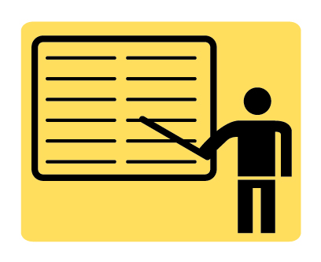 | 1. SLIDE 1 CH8 REAR SUSPENSIONS & SERVICE
 | Check for VIDEOS & ANIMATIONS @ http://www.jameshalderman.com/  WEB SITE IS CONSTANTLY UPDATED
 | Suspension System (55 Links)
 | At the beginning of this class, you can download the crossword puzzle & Word Search from the links below to familiarize your class with the terms in this chapter & then discuss them
 | Crossword Puzzle (Microsoft Word) (PDF)  Word Search Puzzle (Microsoft Word) (PDF)
2. SLIDE 2 EXPLAIN Figure 8-1 Solid axles are used on rear-wheel-drive vehicles as well as front-wheel-drive vehicles.
3. SLIDE 3 EXPLAIN Figure 8-2 solid axle supports the springs, so the axle and suspension components are unsprung weight. When one wheel rides over a bump, the force of impact transfers through the solid axle to the opposite side, leading to unstable handling
4. SLIDE 4 EXPLAIN Figure 8-3 When the axle housing reacts against the force of axle shaft rotation, the front of the differential tilts upward, creating axle windup.
 | DISCUSSION: Ask the students to discuss what Hotchkiss drives are and why they are called Hotchkiss drives.
5. SLIDE 5 EXPLAIN Figure 8-4 typical rear-wheel-drive pickup truck rear suspension equipped with leaf springs. This type of arrangement is called a Hotchkiss drive and the drive train forces are controlled by the rear suspension components.
6. SLIDE 6 EXPLAIN Figure 8-5 An exploded view of a beam axle with multi-leaf springs
 | DEMONSTRATION: Show examples of leaf springs
 | DISCUSSION: Ask the students to discuss why some rear suspensions use one set of trailing arms while other rear suspensions use two sets.
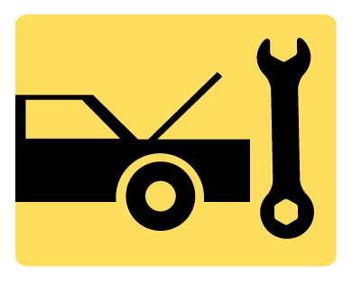 | ON-VEHICLE NATEF TASK: Remove, inspect, and install leaf springs, leaf spring insulators (silencers), shackles, brackets, bushings, and mounts
7. SLIDE 7 EXPLAIN Figure 8-6 A trailing arm rear suspension with a solid axle used on a front-wheel-drive vehicle.
8. SLIDE 8 EXPLAIN Figure 8-7 Camaro and Firebird rear suspension systems use a torque arm to control axle windup. If rubber torque arm bushings (cushions) are worn, a loud “bang” could be heard and felt when accelerating suddenly.
Broken Panhard Rod will cause tires to
hit wheel house when cornering:
FIGURE 8-7
 | DISCUSSION: Ask the students to discuss how the length of a Panhard Rod will affect rear axle movement: FIGURE 8-7
9. SLIDE 9 EXPLAIN Figure 8-8 typical beam axle rear suspension, which uses trailing arms and coil springs along with a track rod, also called a Panhard rod, to control side-to-side axle movement.
10. SLIDE 10 EXPLAIN Figure 8-9 This Ford rear suspension uses upper & lower semi-trailing arms to mount rear axle & watts linkage to control side-to-side movement.
 | DISCUSSION: Ask the students to discuss which is better: rear suspension with a trailing arm or a rear suspension with a semitrailing arm.
11. SLIDE 11 EXPLAIN Figure 8-10 independent rear suspension provides a better ride because less weight is unsprung and the suspension is able to react quickly to bumps in the road without affecting the opposite side.
12. SLIDE 12 EXPLAIN Figure 8-11 A typical short/long-arm independent rear suspension.
13. SLIDE 13 EXPLAIN Figure 8-12 independent rear suspension uses a MacPherson strut, two parallel lower transverse control arms, and a trailing arm.
14. SLIDE 14 EXPLAIN Figure 8-13 toe-control rod provides an extra brace to keep the rear wheels straight ahead during braking and acceleration on this modified-strut-type independent rear suspension.
15. SLIDE 15 EXPLAIN FIGURE 8.14 A transverse mono-type leaf spring used on rear suspension of a Corvette.
 | DISCUSSION: Ask the students to discuss which is better: a transverse-leaf-spring independent rear suspension that uses an H-shaped lower control arm, or a transverse-leaf spring suspension that uses two parallel lower links and a trailing arm
16. SLIDE 16 EXPLAIN Figure 8-15 crossbeam is placed toward front of vehicle rather than the centerline of the rear wheels on a semi-independent- type rear suspension.
17. SLIDE 17 EXPLAIN FIGURE 8–16 A semi-independent rear suspension with MacPherson struts
18. SLIDE 18 EXPLAIN Figure 8-17 Check all rubber bushings for excessive cracking.
19. SLIDE 19 EXPLAIN Figure 8-18 Carefully inspect bump stops for damage during visual inspection.
20. SLIDE 20 EXPLAIN Figure 8-19 A broken spring was discovered during a routine under-vehicle visual inspection. Notice the witness marks that show that the spring coils have been hitting each other.
21. SLIDE 21 EXPLAIN Figure 8-20 The shock absorber needs to be disconnected before removing the coil spring. Installation is the reverse of removal procedure.
22. SLIDE 22 EXPLAIN Figure 8-21 The center bolt is used to hold the leaves of the leaf spring together. However, the hole for the center bolt also weakens the leaf spring. The crack shown is what a technician discovered when the leaf spring was removed during the diagnosis of a sagging rear suspension.
23. SLIDE 23 EXPLAIN FIGURE 8.22 Whatever was leaking appeared to be a clear liquid but it did not smell like gasoline. What could it be from the rear of the truck?
23. SLIDE 23 EXPLAIN FIGURE 8.23 source of the leak was discovered to be hydraulic shock fluid that had leaked from the bottom of the shock and not from around the shaft seal, which is the most likely location for shocks to leak.
 | DISCUSSION: Ask the students to discuss causes of leaf spring breakage other than metal fatigue, corrosion, & overloading
 | DEMONSTRATION: Show the students how to use a pry bar for rear suspension servicing
 | DISCUSSION: Ask the students to discuss why the tops of some rear shocks are fastened inside vehicles
 | Be sure to check OEM service information before removing shock absorbers.

