Automotive Steering, Suspension, & Alignment 7th Ed

Chapter 2 Environmental and Hazardous Materials

Opening Your Class
KEY ELEMENT | EXAMPLES
Introduce Content | This course or class covers operation and service of Automotive Steering and Suspension Systems with Wheel Alignment and Drive Axles. It correlates material to task lists specified by ASE and NATEF.
Motivate Learners | Explain how the knowledge of how something works translates into the ability to use that knowledge to figure why the engine does not work correctly and how this saves diagnosis time, which translates into more money.
State the learning objectives for the chapter or course you are about to cover and explain this is what they should be able to do as a result of attending this session or class. | Explain the chapter learning objectives to the students.  1. Identify hazardous waste materials in accordance with state and federal regulations and follow safety precautions while handling and disposing of hazardous waste materials.  This chapter will help you prepare for the ASE assumed knowledge content required by all service technicians to adhere to environmentally appropriate actions and behavior.
Establish the Mood or Climate | Provide a WELCOME, Avoid put downs and bad jokes.
Complete Essentials | Restrooms, breaks, registration, tests, etc.
Clarify and Establish Knowledge Base | Do a round robin of the class by going around the room and having each student give their backgrounds, years of experience, family, hobbies, career goals, or anything they want to share.

NOTE: This lesson plan is based on Automotive Steering, Suspension, & Alignment 7th Edition Chapter Images found on Jim’s web site @ www.jameshalderman.com

LINK CHP 2: Chapter Images

ICONS | Ch02 Environmental & Hazardous Materials
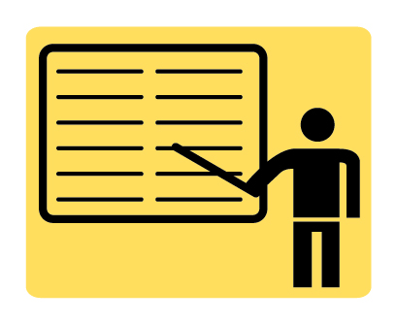 | 1. SLIDE 1 ENVIRONMENTAL & HAZMAT  2. SLIDE 2 EXPLAIN OBJECTIVES
Check for ADDITIONAL VIDEOS & ANIMATIONS @ http://www.jameshalderman.com/
WEB SITE IS CONSTANTLY UPDATED
 | Videos
 | At the beginning of this class, you can download the crossword puzzle & Word Search from the links below to familiarize your class with the terms in this chapter & then discuss them
Crossword Puzzle (Microsoft Word) (PDF)
Word Search Puzzle (Microsoft Word) (PDF)
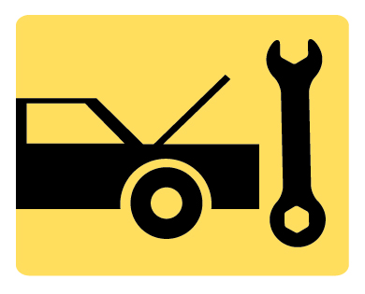 | Research on Internet EPA’s list of Hazardous Materials. Students use Internet & go on the EPA Web Site
 | Ozone Depletion (View) (Download)
Discuss which of these is found in an Automotive Shop or School Lab
Host Discussion on Hazardous materials found in LAB
 | 2. SLIDE 2 EXPLAIN FIGURE 2.1 Material safety data sheets (MSDS) should be readily available for use by anyone in the area who may come into contact with hazardous materials
 | SHOW & EXPLAIN MSDS Sheet: Show an example of MSDS sheet & explain it different sections
 | Complete TASK SHEET on MSDS
3. SLIDE 3 EXPLAIN FIGURE 2.2 Tags identify that the power has been removed and service work is being done.
4. SLIDE 4 EXPLAIN FIGURE 2.3 All brakes should be moistened with water or solvent to help prevent brake dust from becoming airborne
 | DEMOnstration: SHOW students WET-DOWN procedure for brakes like Figure 2-3
DEMOnstration: SHOW students how to dispose of Brake Fluid
DEMOnstration: show corrosiveness of brake fluid by pouring on painted object
5. SLIDE 5 EXPLAIN FIGURE 2.4 A typical aboveground oil storage tank.
6. SLIDE 6 EXPLAIN FIGURE 2.5 Washing hands and removing jewelry are two important safety habits all service technicians should practice.
 | DEMOnstration: Cut top off old Oil Filter. Show students filtering element & all of particles it has filtered. this is reason why you have to drain filter before disposAL
 | Hold discussion on solvents used in shop. Ask studetns to discuss common solvents used in the shop
7. SLIDE 7 EXPLAIN FIGURE 2.6 Typical fireproof flammable storage cabinet
8. SLIDE 8 EXPLAIN FIGURE 2.7 Using a water-based cleaning system helps reduce the hazards from using strong chemicals.
9. SLIDE 9 EXPLAIN FIGURE 2.8 Used antifreeze coolant should be kept separate and stored in a leakproof container until it can be recycled or disposed of according to federal, state, and local laws. Note that the storage barrel is placed inside another container to catch any coolant that may spill out of the inside barrel.
 | 10. SLIDE 10 EXPLAIN FIGURE 2.9 This red gasoline container holds about 30 gallons of gasoline and is used to fill vehicles used for training.
 | Have students research Internet for what is done with recycled automotive tires
11. SLIDE 11 EXPLAIN FIGURE 2.10 Air-conditioning refrigerant oil must be kept separated from other oils because it contains traces of refrigerant and must be treated as hazardous waste.
12. SLIDE 12 EXPLAIN FIGURE 2.11 Placard near driver’s door, including what devices in the vehicle contain mercury.
13. SLIDE 13 EXPLAIN FIGURE 2.12 The OSHA global hazardous materials labels..
 | Host DISCUSSION ON the different REFRIGERANTS & Refrigerant OILS

