Automotive Steering, Suspension, & Alignment 7e

Chapter 15 Wheel Bearings and Service

Opening Your Class
KEY ELEMENT | EXAMPLES
Introduce Content | This course or class covers operation and service of Automotive Steering and Suspension Systems with Wheel Alignment and Drive Axles. It correlates material to task lists specified by ASE and NATEF
Motivate Learners | Explain how the knowledge of how something works translates into the ability to use that knowledge to figure why the engine does not work correctly and how this saves diagnosis time, which translates into more money.
State the learning objectives for the chapter or course you are about to cover and explain this is what they should be able to do as a result of attending this session or class. | Explain the chapter learning objectives to the students.  1. Explain the different types of antifriction bearings, bearing greases, and seals.  2. Explain the diagnosis of defective wheel bearings.  3. Discuss rear drive axle classifications and the procedure to replace rear axle bearings and seals.  4. State the reasons for bearing failure.  This chapter will help you prepare for the Steering and Suspension (A4) ASE certification test content area “C” (Related Suspension and Steering Service).
Establish the Mood or Climate | Provide a WELCOME, Avoid put downs and bad jokes.
Complete Essentials | Restrooms, breaks, registration, tests, etc.
Clarify and Establish Knowledge Base | Do a round robin of the class by going around the room and having each student give their backgrounds, years of experience, family, hobbies, career goals, or anything they want to share.

NOTE: This lesson plan is based on Automotive Steering, Suspension, & Alignment 7th Edition Chapter Images found on Jim’s web site @ www.jameshalderman.com

LINK CHP 15: Chapter Images

ICONS | Ch15 Wheel Bearings and Service
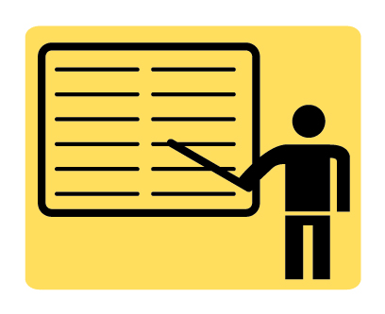 | 1. SLIDE 1 WHEEL BEARINGS & SERVICE
 | Check for ADDITIONAL VIDEOS & ANIMATIONS @ http://www.jameshalderman.com/  WEB SITE IS CONSTANTLY UPDATED
 | Videos
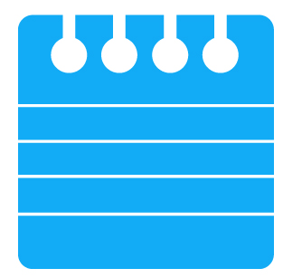 | At the beginning of this class, you can download the crossword puzzle & Word Search from the links below to familiarize your class with the terms in this chapter & then discuss them
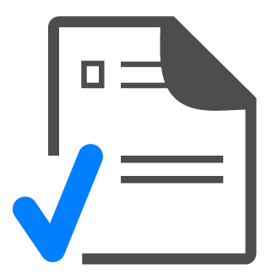 | Word Search Puzzle (Microsoft Word) (PDF)  Word Search Puzzle (Microsoft Word) (PDF
2. SLIDE 2 EXPLAIN Figure 15-1 Rolling contact bearings include (left to right) ball, roller, needle, and tapered roller.
3. SLIDE 3 EXPLAIN Figure 15-2 Ball bearing point contact
4. SLIDE 4 EXPLAIN FIGURE 15-3 Radial load is the vehicle weight pressing on wheels. The thrust load occurs as chassis components exert a side force during cornering.
5. SLIDE 5 EXPLAIN Figure 15-4 Roller bearing line contact.
6. SLIDE 6 EXPLAIN Figure 15-5 A tapered roller bearing will support a radial load and an axial load in only one direction.
7. SLIDE 7 EXPLAIN Figure 15-6 Many tapered roller bearings use a plastic cage to retain the rollers.
8. SLIDE 8 EXPLAIN Figure 15-7 Non-drive-wheel hub with inner and outer tapered roller bearings. By angling the inner and outer in opposite directions, axial (thrust) loads are supported in both directions.
 | Wheel Bearing Assembly
 | DEMONSTRATION: Show examples of ball bearings. What is their advantage over roller bearings, & where are ball bearings most often used on vehicles? Show examples of roller bearings. What is their advantage over ball bearings?
 | DISCUSSION: Ask students to discuss the role of antifriction bearings in reducing friction—allowing wheels to rotate while supporting vehicle’s weight. Have students name 4 types of antifriction bearings.
 | DEMONSTRATION: Show examples of needle bearings. Where might needle bearings be used instead of roller bearings? Show students examples of tapered roller bearings. What about the design of these bearings makes them the most used automotive wheel bearing? Show students the placement of inner and outer wheel bearings. Why are the inner wheel bearings always larger?
 | DISCUSSION: Ask students to discuss difference between axial, or thrust, and radial loads and how tapered roller bearings accommodate both.
9. SLIDE 9 EXPLAIN Figure 14-8 Sealed bearing and hub assemblies are used on front and rear wheels of many vehicles.
10. SLIDE 10 EXPLAIN Figure 14-9 Sealed bearing and hub assemblies are serviced as a complete unit as shown. This assembly includes the wheel speed sensor.
 | On non-drive tapered wheel bearings inner race must slide smoothly over the spindle.
 | DISCUSSION: Ask students to discuss the National Lubricating Grease Institute (NLGI) grease penetration test. What is signified by low and high numbers? What do the quality ratings indicate? What types of grease would be used for the wheel bearings of cars students are working on? Grease is used on wheel bearings to reduce friction further. Ask students to discuss types of grease and the purpose of additives in them.
11. SLIDE 11 EXPLAIN Figure 15-10 Typical lip seal with a garter spring
12. SLIDE 12 EXPLAIN Figure 15-11 garter spring helps hold sharp lip edge of the seal tight against shaft.
 | DEMONSTRATION: Show students examples of a dynamic seal and the garter spring used to hold the lip of the seal in place
 | DISCUSSION: Ask students to talk about the purpose and function of seals, and discuss the difference between static and dynamic seals.
 | DISCUSSION: Ask students to discuss symptoms of defective bearings and how to diagnose the exact problem. Ask students to describe the sound of defective wheel bearings and discuss its cause.
 | To determine location of a bearing noise drive vehicle along a high solid wall about six feet away with window open. Then drive by again going other way. The noise will echo off wall and help you to hear it.
 | DISCUSSION: Ask students to identify symptoms of a defective wheel bearing
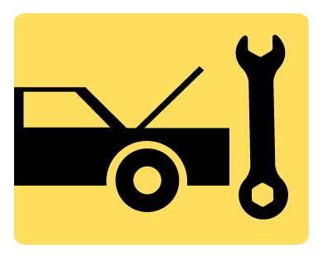 | ON-VEHICLE NATEF TASK Diagnose wheel bearing noises, wheel shimmy, and vibration concerns; determine necessary action.
13. SLIDE 13 EXPLAIN Figure 15-12 Removing the grease cap with grease cap pliers
14. SLIDE 14 EXPLAIN Figure 15-13 Using a seal puller to remove the grease seal.
 | DEMONSTRATION: Show how to remove inner wheel bearing & grease seal. Show how to use wheel bearing race puller. Show how to install bearing race
 | DEMONSTRATION: Show students how to remove a wheel grease cap to access the outer wheel bearing. Show students how to do the wheel bearing looseness test. Ask them to describe some of problems that loose wheel bearings can cause.
15. SLIDE 15 EXPLAIN Figure 14-14 Cleaning a wheel bearing with a parts brush and solvent
16. SLIDE 16 EXPLAIN Figure 15-15 wheel bearing race puller.

 | HANDS-ON TASK: Have students follow steps to perform a non-drive wheel bearing inspection and replace and grease any defective bearings they find. Select a student to summarize the process and results for the class
17. SLIDE 17 EXPLAIN Figure 15-16 Installing a bearing race with a driver
18. SLIDE 18 EXPLAIN BEARING CHART
19. SLIDE 19 EXPLAIN Figure 15-17 Notice the new blue grease has been forced through the bearing.
20. SLIDE 20 EXPLAIN Figure 15-18 commonly used hand-operated bearing packer
21. SLIDE 21 EXPLAIN Figure 15-19 The wheel bearing is placed between two nylon cones and then a grease gun is used to inject grease into the center of the bearing.
22. SLIDE 22 EXPLAIN Figure 15-20 wheel bearing adjustment procedure as specified for rear-wheel-drive vehicles. Always check service information for exact specified procedure for vehicle being serviced
23. SLIDE 23 EXPLAIN Figure 15-21 properly secured wheel bearing adjustment nut.
 | HANDS-ON TASK: Have students perform wheel bearing adjustment procedure for rear-wheel drive vehicle by using a torque wrench. Have students repack a bearing with bearing packer and with their hands
 | ON-VEHICLE NATEF TASK Remove, clean, inspect, repack, and install wheel bearings.
 | ON-VEHICLE NATEF TASK Replace wheel bearing and race.
 | ON-VEHICLE NATEF TASK Inspect and replace wheel studs.
24. SLIDE 24 EXPLAIN Figure 15-22 A rear wheel sealed bearing hub assembly.
25. SLIDE 25 EXPLAIN Figure 15-23 Removing the drive axle shaft hub nut. This nut is usually very tight and the drift (tapered) punch wedged into the cooling fins of the brake rotor keeps the hub from revolving when the nut is loosened. Never use an impact to remove or install a drive axle shaft hub nut because the hammering action can damage the bearing.
26. SLIDE 26 EXPLAIN Figure 15-24 A special puller makes the job of removing the hub bearing from the knuckle easy without damaging any component.
 | ON-VEHICLE NATEF TASK Remove & install sealed wheel bearing assembly.
27. SLIDE 27 EXPLAIN Figure 15-25 A typical full-floating rear axle assembly.
28. SLIDE 28 EXPLAIN FIGURE 15.26 A three-quarter-floating rear axle.
29. SLIDE 29 EXPLAIN Figure 15-27 semi-floating rear axle housing is the most commonly used in light rear-wheel-drive vehicles
30. SLIDE 30 EXPLAIN Figure 15-28 A retainer plate-type rear axle bearing. Access to the fasteners is through a hole in the axle flange.
 | 31. SLIDE 31 EXPLAIN Figure 15-29 slide hammer-type axle puller can also be used.
32. SLIDE 32 EXPLAIN Figure 15-30 To remove the axle from this vehicle equipped with a retainer-plate rear axle, the brake drum was placed back onto the axle studs backward so that the drum itself can be used as a slide hammer to pull the axle out of the axle housing. A couple of pulls and the rear axle is pulled out of the axle housing
33. SLIDE 33 EXPLAIN Figure 15-31 To remove the C-lock (clip), the lock bolt has to be moved before the pinion shaft.
34. SLIDE 34 EXPLAIN Figure 15-32 The axle must be pushed inward slightly to allow the C-lock to be removed. After the C-lock has been removed, the axle can be easily pulled out of the axle housing.
35. SLIDE 35 EXPLAIN Figure 15-33 Using a hydraulic press to press an axle bearing from the axle. When pressing a new bearing back onto the axle, pressure should only be on the inner bearing race to prevent damaging the bearing.
36. SLIDE 36 EXPLAIN Figure 15-34 Removing an axle seal using the axle shaft as the tool
 | DISCUSSION: Ask students to talk about C-lock rear axles. What type of bearing is used with this axle? How do you lubricate axle bearing? How do you remove this type of axle to service bearings?
 | DEMONSTRATION: Show students how to do drum slide hammer trick to remove an axle from a vehicle equipped with a retainer-plate rear axle. Show students how to safely remove lock bolt from carrier. Care must be taken to not break bolt in carrier.
37. SLIDE 37 EXPLAIN Figure 15-35 To detect a possible defective wheel bearing, grasp the coil spring and then rotate the wheel. If there is roughness in the bearing, a vibration will be felt in the spring.
38. SLIDE 38 EXPLAIN Figure 15-36 This bearing has a bent cage and must be replaced.
39. SLIDE 39 EXPLAIN Figure 15-37 FIGURE 15.37 A bearing/hub assembly that shows the reluctor (tone wheel) teeth used by the wheel speed sensor.
 | 40. SLIDES 40-48 EXPLAIN REAR AXLE BEARING REPLACEMENT
 | HOMEWORK: Have students research work of John Harrison, an English clockmaker who invented the first practical caged roller bearing in the mid-1740s.

