Automotive Steering, Suspension, & Alignment 7e

Chapter 12 Steering Linkage & Service

Opening Your Class
KEY ELEMENT | EXAMPLES
Introduce Content | This course or class covers operation and service of Automotive Steering and Suspension Systems with Wheel Alignment and Drive Axles. It correlates material to task lists specified by ASE and NATEF
Motivate Learners | Explain how the knowledge of how something works translates into the ability to use that knowledge to figure why the engine does not work correctly and how this saves diagnosis time, which translates into more money.
State the learning objectives for the chapter or course you are about to cover and explain this is what they should be able to do as a result of attending this session or class. | Explain learning objectives to students as listed below:  1. Identify steering linkage components.  2. Describe rack-and-pinion inner tie rod ends.  3. Describe four-wheel steering systems.  4. Describe how to perform a dry park test to determine the condition of steering system components.  5. Explain how to replace steering linkage parts.  This chapter will help prepare for ASE Suspension and Steering (A4) certification test content area “A” (Steering System Diagnosis and Repair).
Establish the Mood or Climate | Provide a WELCOME, Avoid put downs and bad jokes.
Complete Essentials | Restrooms, breaks, registration, tests, etc.
Clarify and Establish Knowledge Base | Do a round robin of the class by going around the room and having each student give their backgrounds, years of experience, family, hobbies, career goals, or anything they want to share.

NOTE: This lesson plan is based on Automotive Steering, Suspension, & Alignment 7th Edition Chapter Images found on Jim’s web site @ www.jameshalderman.com

LINK CHP 12: Chapter Images

ICONS | Chapter 12 Steering Linkage & Service
 | 1. SLIDE 1 CH12 STEERING LINKAGE & SERVICE
 | Check for VIDEOS & ANIMATIONS @ http://www.jameshalderman.com/  WEB SITE IS CONSTANTLY UPDATED
 | Steering System (62 Links)
 | At the beginning of this class, you can download the crossword puzzle & Word Search from the links below to familiarize your class with the terms in this chapter & then discuss them
 | Crossword Puzzle (Microsoft Word) (PDF)  Word Search Puzzle (Microsoft Word) (PDF)
 | If a customer complains of a pull to one side or other, check the steering linkage. One of the parts could have worked loose.
GM Steering Wheel Removal (View) (Download)
Rack and Pinion Gear Remove and Replace (View) (Download)
Steering Linkage Operation (View) (Download)
2. SLIDE 2 EXPLAIN Figure 12-1 Steering movement is transferred from the pitman arm that is splined to the sector shaft (pitman shaft), through the center link and tie rods, to the steering knuckle at each front wheel. The idler arm supports the passenger side of the center link and keeps the steering linkage level with the road. This type of linkage is called a parallelogram-type design.
3. SLIDE 3 EXPLAIN Figure 12-2 most common type of steering is parallelogram. The cross-steer and Haltenberger linkage designs are used on some trucks and vans.
 | DEMONSTRATION: Show example of parallelogram steering linkage. FIGURE 12-2. Show examples of steering dampeners used on trucks, vans, & some luxury cars. FIGURE 12-3
4. SLIDE 4 EXPLAIN Figure 12-3 Typical steering dampener used on a Hummer H2.
5. SLIDE 5 EXPLAIN Figure 12-4 (a) A dual bearing design with 2 preload spring. Use of 2 bearing surfaces allows for one surface for rotation (for steering) and another surface for pivoting (allow for suspension up-and-down movement). (b) Nylon wedge bearing type allows for extended lube intervals. Wear is compensated for by tapered design & spring-loaded bearing.
 | 6. SLIDE 6 EXPLAIN Figure 12-5 (a) A rubber-bonded socket is constructed of a rubber casing surrounding the ball stud, which is then inserted into the socket of the tie rod end. The hole in the socket allows air to escape as the ball stud is installed and there is not a place for a grease fitting. (b) The socket is crimped over the ball so that part of the socket lip retains the stud.
7. SLIDE 7 EXPLAIN Figure 12-6 Rack-&-Pinion steering systems use ball & socket-type inner tie rod end.
8. SLIDE 8 EXPLAIN Figure 12-7 variety of methods are used to secure the inner tie rod end socket assembly to the end of the rack
 | DEMONSTRATION: Show examples of roll pin, set screw, and swaged socket types of inner tie rod end assemblies used in rack-and-pinion steering systems: FIGURES 12-5, 6, & 7
 | 9. SLIDE 9 EXPLAIN Figure 12-8 Exploded view of a center-take-off-style rack-and-pinion steering gear assembly
 | DEMONSTRATION: Show examples of center-take-off rack-and-pinion steering gear assemblies: FIGURES 12-8
 | Some center-take-off rack-and-pinion steering gear assemblies also include an adjuster stud for adjusting linkage length. Be sure to check type of assembly before beginning work.
 | 10. SLIDE 10 EXPLAIN Figure 12-9 In rear-steer vehicle, steering linkage is behind the centerline of front wheels, whereas the linkage is in front on a front-steer vehicle.
 | DISCUSSION: Ask the students to discuss whether front steer or rear steer is better: FIGURES 12-9
 | 11. SLIDE 11 EXPLAIN Figure 12-10 Opposite-phase 4-wheel steer is usually used only at low vehicle speed to help in parking maneuvers. Same-phase steering helps at higher speeds & may not be noticeable by average driver
12. SLIDE 12 EXPLAIN Figure 12-11 Being equipped with four-wheel steer allows a truck to make shorter turns than would otherwise be possible.
13. SLIDE 13 EXPLAIN Figure 12-12 Quadrasteer includes many components that all work together.
14. SLIDE 14 EXPLAIN Figure 12-13 dash-mounted select switch showing three positions for 4-wheel steer system.
15. SLIDE 15 EXPLAIN Figure 12-14 Quadrasteer system showing all of the components. Motor used to power rear steering rack can draw close to 60 amperes during a hard turn and can be monitored using a Tech 2.
16. SLIDE 16 EXPLAIN Figure 12-15 Greasing a tie rod end. Some joints do not have a hole for excessive grease to escape, and excessive grease can destroy the seal
17. SLIDE 17 EXPLAIN Figure 12-16 Part of steering linkage lubrication is applying grease to the steering stops
18. SLIDE 18 EXPLAIN Figure 12-17 Checking for freeplay in the steering.
19. SLIDE 19 EXPLAIN Figure 12-18 All joints should be felt during a dry park test. Even inner tie rod ends (ball socket assemblies) can be felt through the rubber bellows on many rack-and-pinion steering units.
 | DISCUSSION: Ask students to discuss steering systems similar to GM Quadrasteer™ system FIGURES 12-12
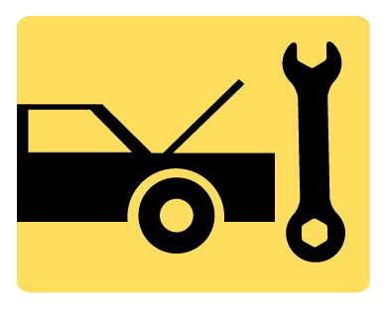 | DEMONSTRATION: Show examples of Zerk fittings, both in hand and on the vehicle.
 | DEMONSTRATION: Show examples of grease guns and grease cartridges. Show how to use a grease gun and cartridge to grease a tie rod end
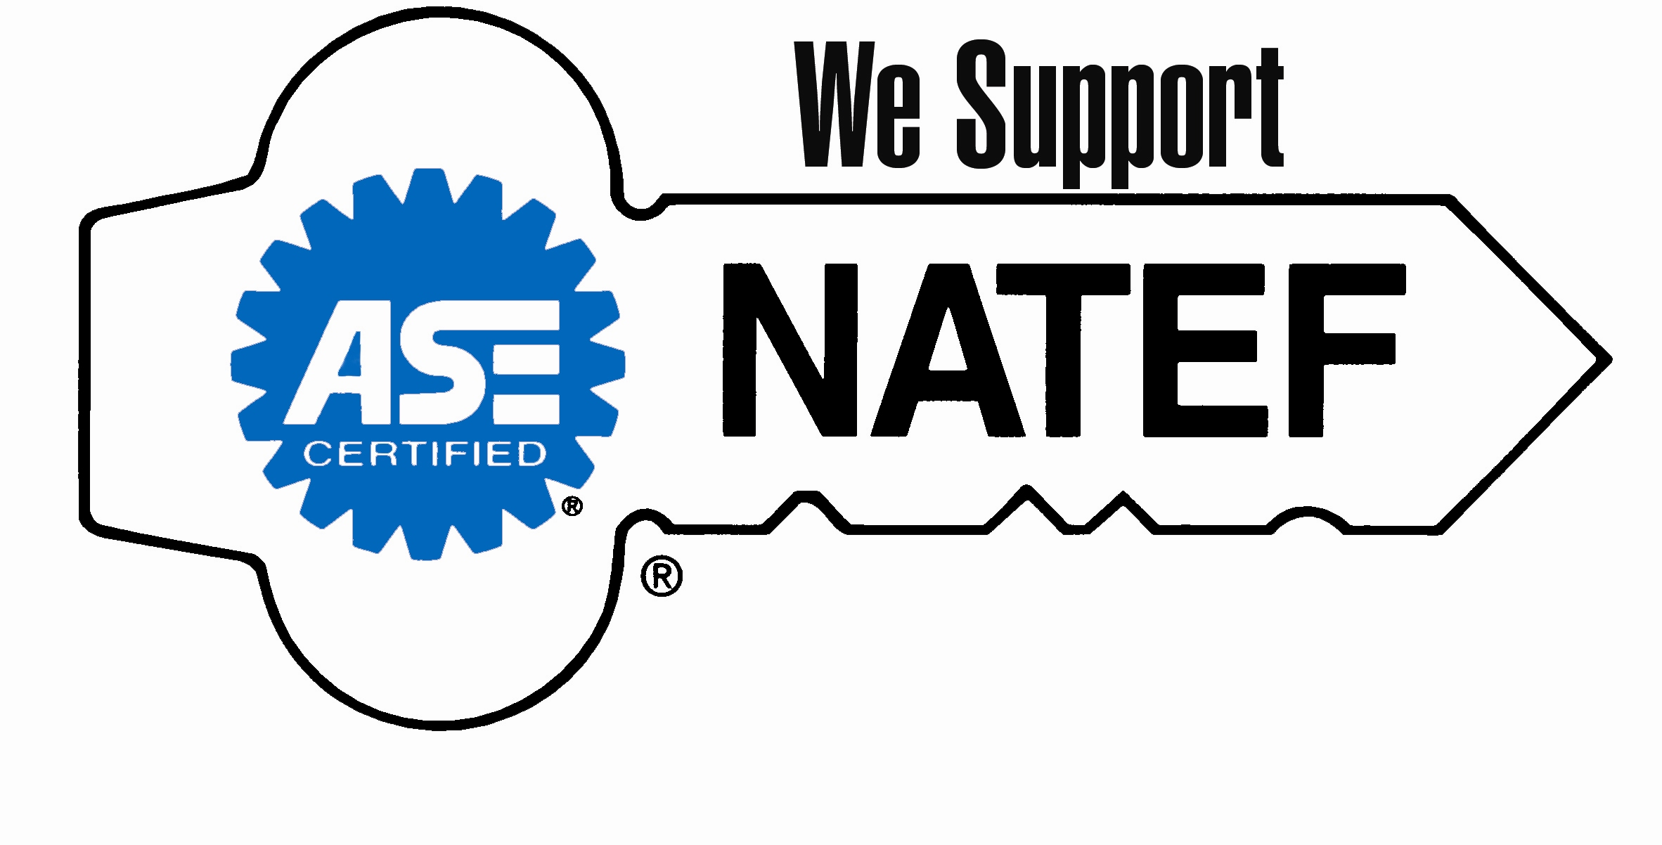 | ON-VEHICLE NATEF TASK: Lubricate Suspension and steering system
20. SLIDE 20 EXPLAIN Figure 12-19 The steering and suspension arms must remain parallel to prevent the up-and-down motion of the suspension from causing the front wheels to turn inward or outward.
21. SLIDE 21 EXPLAIN Figure 12-20 center link should be parallel to the ground
22. SLIDE 22 EXPLAIN Figure 12-21 Typical parallelogram steering linkage. The center link can also be named the relay rod, drag link, or connecting link.
 | 23. SLIDE 23 EXPLAIN Figure 12-22 Some center links have ball joints while others have tapered socket holes to accept ball joints on the pitman arm, idler arm, and inner tie rod ends.
 | 24. SLIDE 24 EXPLAIN Figure 12-23 To check an idler arm, most vehicle manufacturers specify that 25 pounds of force be applied by hand up and down to the idler arm
 | DEMONSTRATION: Show how to check an idler arm to determine if it needs to be replaced FIGURE 12-23
 | DEMONSTRATION: Show how to check steering components by using the dry park test:
HANDS-ON TASK: Have the students do a
Dry Park Test: FIGURES 12-23, 24, 25
25. SLIDE 25 EXPLAIN FIGURE 12–24 Steering system component(s) should be replaced if any noticeable looseness is detected when moved by hand.
26. SLIDE 26 EXPLAIN FIGURE 12–25 All joints should be checked by hand for any lateral or vertical play.
 | DEMONSTRATION: Show how to perform jounce/rebound test
 | HANDS-ON TASK: Have students perform jounce/rebound test
27. SLIDE 27 EXPLAIN Figure 12-26 If a rack-and-pinion or any other steering linkage system is not level, the front tires will be moved inward and/or outward whenever the wheels of the vehicle move up or down..
28. SLIDE 28 EXPLAIN FIGURE 12–27 The preferred method for separating the tie rod end from the steering knuckle is to use a puller such as the one shown
Tie Rod End Replace (View) (Download)
Tie Rod End Remove and Replace (View) (Download)
 | ON-VEHICLE NATEF TASK: Identify and interpret steering concerns; determine necessary action.
 | 29. SLIDE 29 EXPLAIN Figure 12-28 Two hammers being used to disconnect a tie rod end from the steering knuckle. One hammer is used as a backing for the second hammer.
 | DISCUSSION: discuss symptoms that would suggest that a tie rod should be replaced
 | DEMONSTRATION: Show how to disconnect a tie rod from steering knuckle. Show examples of a puller tool & pickle-fork tool used to separate the tie rod from steering knuckle: FIGURE 12-28
When a pitman arm is being stubborn, put tension on it with a puller and then hit pitman arm with a hammer. Then retighten puller. Do this several times; and the
pitman arm should fall off.
30. SLIDE 30 EXPLAIN FIGURE 12-29 pitman arm puller is used to remove the pitman arm from the pitman shaft.
31. SLIDE 31 EXPLAIN FIGURE 12-30 Pitman arm and pitman shaft indexing splines.
32. SLIDE 32 EXPLAIN FIGURE 12–31 Align the hole in the tie rod end with the slot in the retaining nut.
 | DISCUSSION: Define Bump Steer. Ask students to discuss how lowering vehicle, or mixing and matching steering components may fix bump steer
 | Bump Steer can be found by placing vehicle on the alignment rack. Pull vehicle down on springs (by adding weight or chaining the car down) and measure toe change. Repeat the procedure, but lift one side of front cross member, then the other. Then lift both sides together. Changes in toe are bump steer.
33. SLIDE 33 EXPLAIN Figure 12-32 Replacement tie rods should be of the same overall length as the originals. Measure from the edge of the tie rod sleeve to the center
of the grease fitting.
34. SLIDE 34 EXPLAIN Figure 12-33 All tie rod ends should be installed so that the stud is in the center of its operating range, as shown.
35. SLIDE 35 EXPLAIN Figure 12-34 (a) Tie rod adjusting sleeve. (b) Be sure to position the clamp correctly on the sleeve.
36. SLIDE 36 EXPLAIN Figure 12-35 An articulation test uses a spring scale to measure the amount of force needed to move the tie rod in the ball socket assembly
37. SLIDE 37 EXPLAIN Figure 12-36 Removing a staked inner tie rod assembly requires two wrenches—one to hold the rack and the other to unscrew the joint from the end of the steering rack.
38. SLIDE 38 EXPLAIN Figure 12-37 When the inner tie rod end is reassembled, both sides of the housing must be
staked down onto the flat shoulder of the rack
39. SLIDE 39 EXPLAIN Figure 12-38 After replacing an inner tie rod end, the socket assembly should be secured with a rivet or set screw depending on the style of the replacement part
 | 40. SLIDE 40 EXPLAIN Figure 12-39 Using an inductive heater caused this retaining nut to be cherry red in a just a few seconds
 | DEMONSTRATION: Show how to remove a staked inner tie rod assembly by using two wrenches. FIGURE 12-36. Show how to remove the roll pin from a pinned rack-and pinion unit by using two methods: using a puller, and drilling out the pin FIGURE 12-37
 | HANDS-ON TASK: Have the students remove roll pins from pinned rack-and-pinion units by drilling out the pins.
 | ON-VEHICLE NATEF TASK: Inspect and replace rack and pinion steering gear inner tie ends (sockets) and bellows boots
 | ON-VEHICLE NATEF TASK: Inspect and replace pitman arm, relay (centerlink/intermediate) rod, idler arm and mountings, and steering linkage damper.
 | ON-VEHICLE NATEF TASK: Inspect, replace, and adjust tie rod ends (sockets), tie rod sleeves and clamps.
 | ON-VEHICLE NATEF TASK: Diagnose conventional & rack and pinion steering gears; determine necessary action.
 | 41. SLIDES 41-48 EXPLAIN OPTIONAL STEERING LINKAGE SERVICE
 | SEARCH INTERNET: Have students use Internet TO research the history of airbags. Ask students to prepare presentations on the history of airbags. Have them share their presentations during the next class.

