Connectors and Terminals

Meets NATEF Task: (A6-A-18) Repair connectors and terminal ends. (P-1)

Name _______________________________ Date ___________ Time on Task __________

Make/Model/Year _________________ VIN ________________ Evaluation: 4 3 2 1

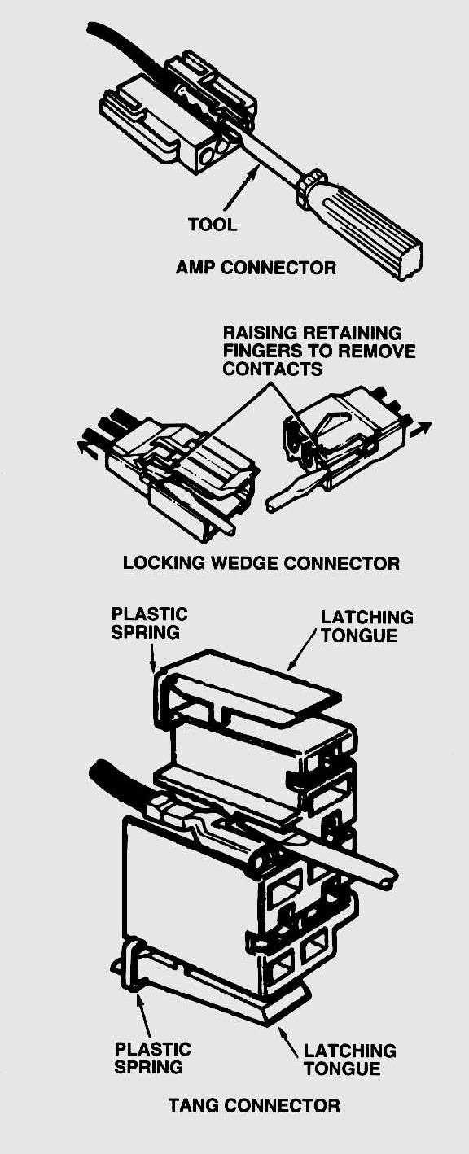
_____ 1. Check service information for the specified tasks and procedures to follow to remove
terminals from connectors and for performing terminal end repairs.

__________________________________________________________________

a. Connector (the plastic component that
makes the mechanical connection).
Number of cavities: _______

b. Terminal (the metal part that makes
the electrical connection:

Type or design: __________________

_____ 2. List the tools needed to separate the terminals
from the connectors:

a. ____________________________
b. ____________________________
c. ____________________________

_____ 3. Does service information require that hand- crimped terminals be soldered?

___ Yes ___ No

_____ 4. Perform the terminal repair.

Instructor’s OK ___________________

