Differential Case Assembly
Meets NATEF Task: (A3-E-1-13) Assemble and install differential case assembly and measure runout; determine necessary action. (P-3)

Name _______________________________ Date ___________ Time on Task __________

Make/Model/Year _________________ VIN ________________ Evaluation: 4 3 2 1

_____ 1. Check service information for the specified procedures for installing the differential case
assembly and measure ring gear runout. Describe the specified procedures. __________
____________________________________________________________________
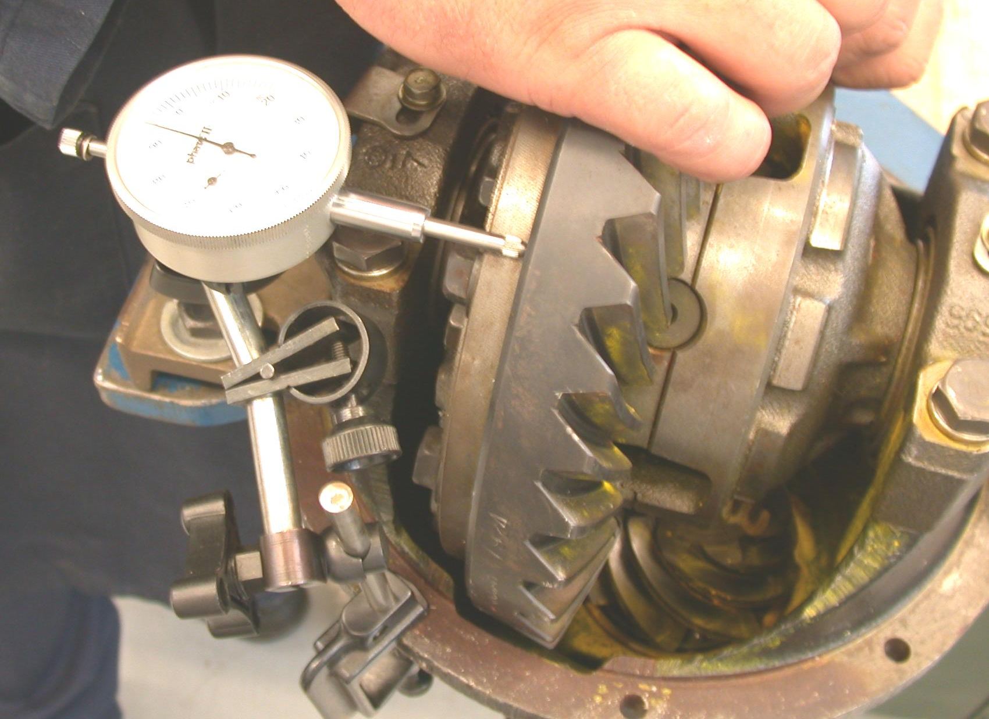
____________________________________________________________________

_____ 2. What is the specified runout? ________________________________________
_____ 3. What is the measured runout? ________________________________________
_____ 4. Based on the inspection and runout measurement, what is the necessary action?
___________________________________________________________________
___________________________________________________________________
___________________________________________________________________

