Differential Side Bearing Preload
Meets NATEF Task: (A3-E-1-10) Measure and adjust side bearing preload.
(P-3)

Name _______________________________ Date ___________ Time on Task __________

Make/Model/Year _________________ VIN ________________ Evaluation: 4 3 2 1

_____ 1. Check service information and determine the specified procedure to follow to adjust side
bearing preload. Describe the procedure. _____________________________________
____________________________________________________________________
____________________________________________________________________
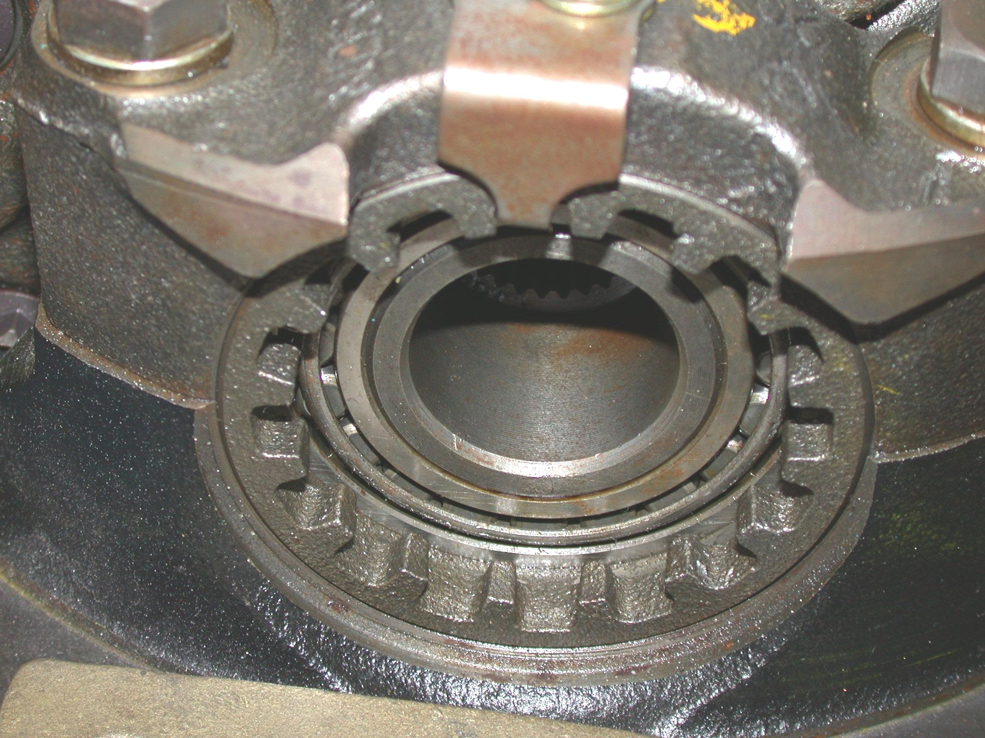
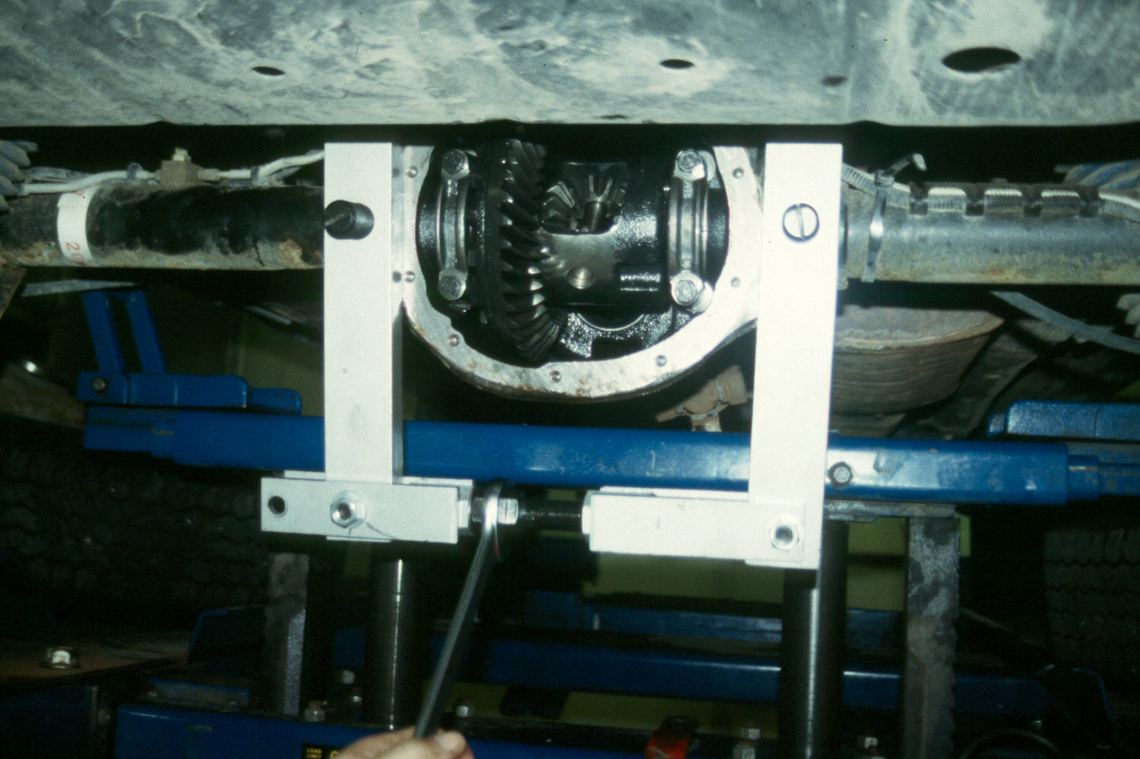
____________________________________________________________________

_____ 2. Which type of differential is being serviced?
____ Shim type
____ Threaded cap

