Drive Pinion Depth
Meets NATEF Task: (A3-E-1-8) Measure and adjust drive pinion depth.
(P-3)

Name _______________________________ Date ___________ Time on Task __________

Make/Model/Year _________________ VIN ________________ Evaluation: 4 3 2 1

_____ 1. Check service information for the specified procedures and drive pinion depth
measurement. Describe the measuring procedure. ______________________________
____________________________________________________________________
____________________________________________________________________
____________________________________________________________________
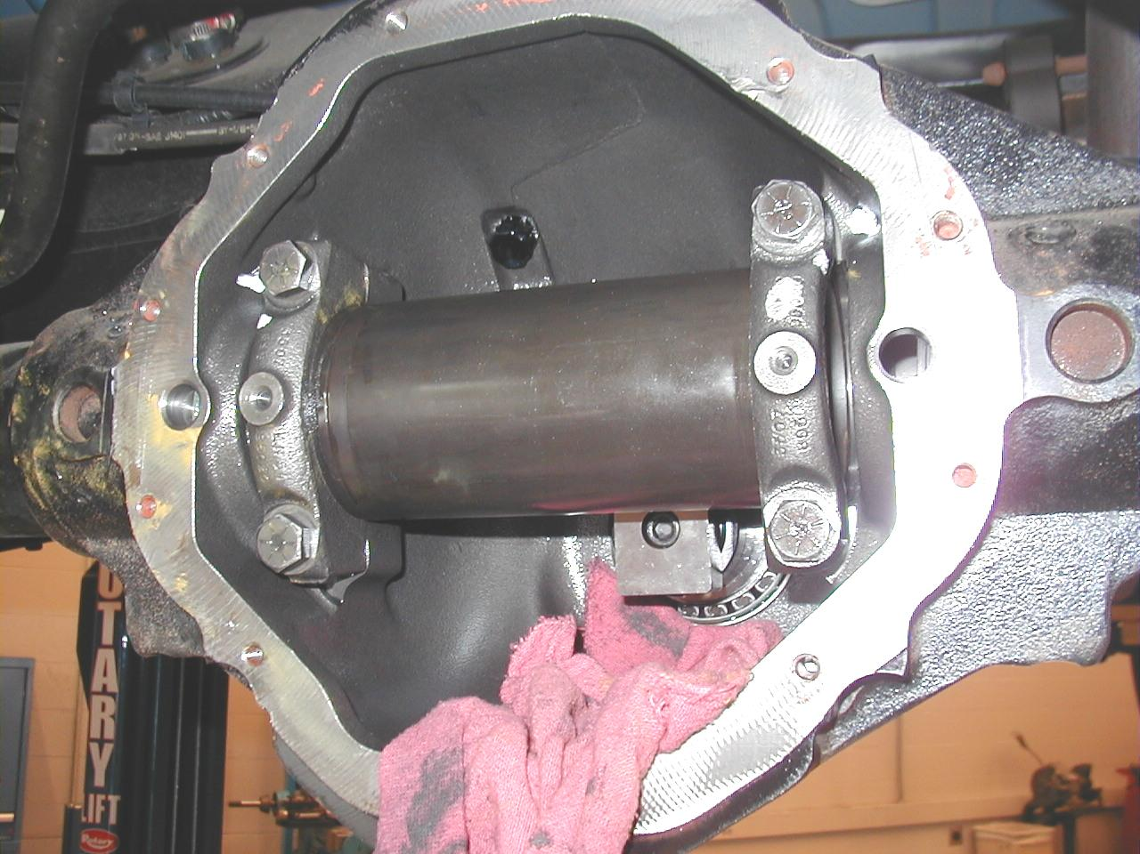

_____ 2. Check service information and determine the specified pinion depth. _______________
___________________________________________________________________
_____ 3. Check service information to determine what mark(s) on the pinion mean. ___________
____________________________________________________________________

