Flywheel and Ring Gear Inspection

Meets NATEF Task: (A3-B-6) Inspect flywheel; determine necessary action. (P-1)

Name _______________________________ Date ___________ Time on Task __________

Make/Model/Year _________________ VIN ________________ Evaluation: 4 3 2 1

_____ 1. Check service information and determine what should be checked when inspecting a
flywheel and ring gear (describe recommended inspection procedure). ______________
____________________________________________________________________
____________________________________________________________________
____________________________________________________________________
____________________________________________________________________
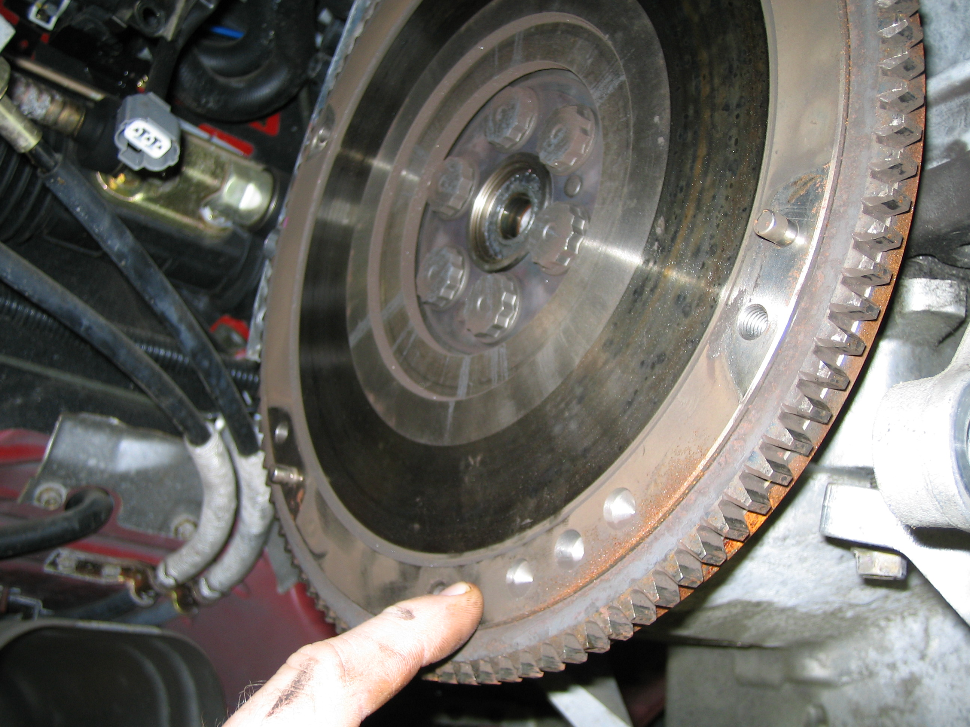

_____ 2. Based on the inspection and the service information recommendations, what is the
necessary action? _______________________________________________________
___________________________________________________________________
___________________________________________________________________

