Evaporator/Heater Core Replacement
Meets NATEF Task: (A7-B-12A7-C-4) Remove, inspect, and reinstall evaporator; determine required oil quantity. (P-3)

Name _______________________________ Date ___________ Time on Task __________

Make/Model/Year _________________ VIN ________________ Evaluation: 4 3 2 1

_____ 1. Check service information and determine the specified procedures to follow to replace
the evaporator. (list the procedures)
a. _______________ d. _______________ g. _______________
b. _______________ e. _______________ h. _______________
c. _______________ f. _______________ i. _______________
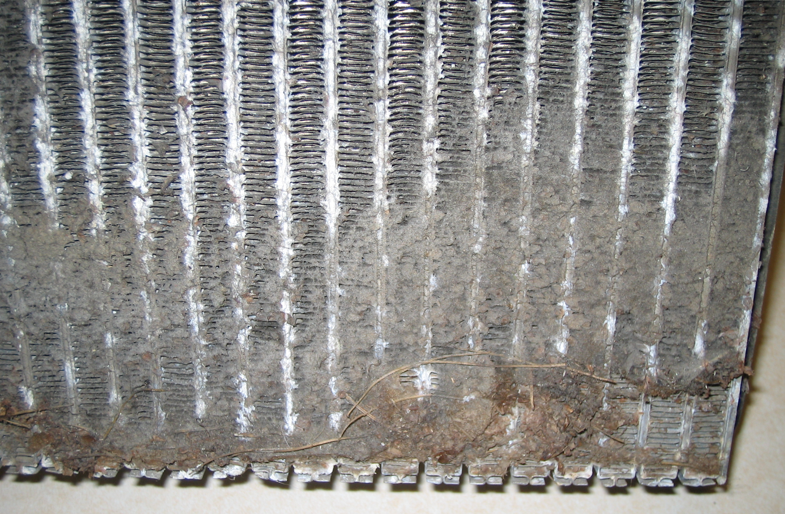

_____ 2. Check service information and determine the amount of oil needed to add to the system
when replacing the component.
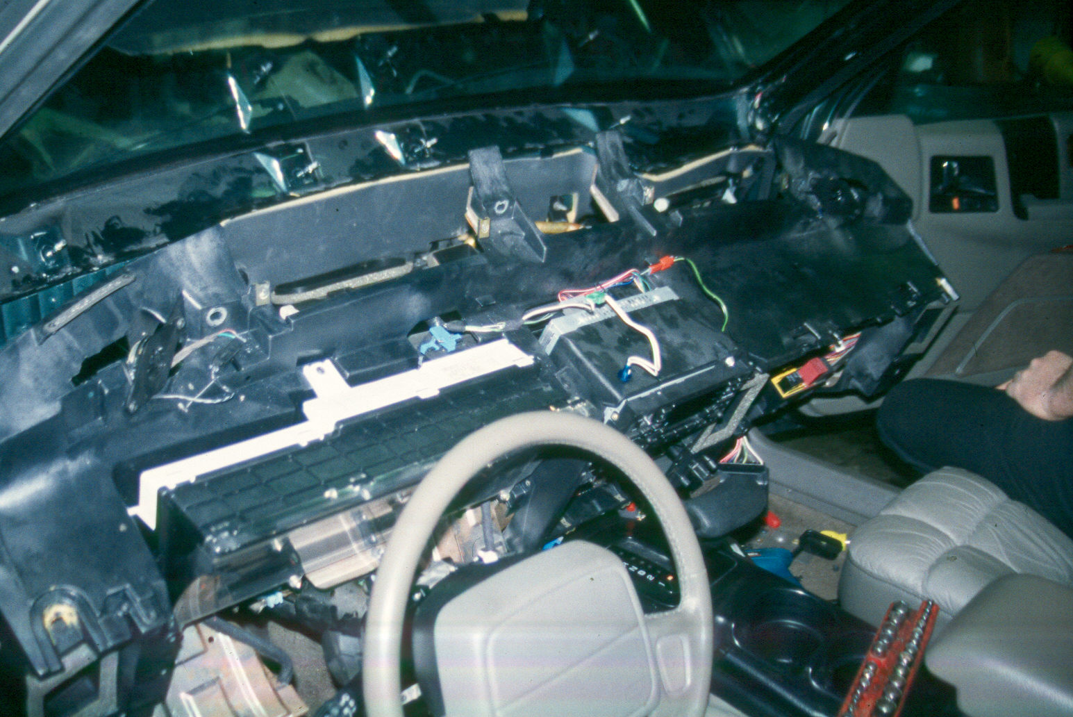
Oil amount = __________ oz.

